Final Year Project Report

XAI For Multimodal Fake News Detection on Social Media


Project Advisor:
Ma’am Hina Tufail

Submitted By:
Syed Taha Faiz-ul-Hassan Rizvi (22002376004)
Ayesha Bukhari (22002376015)
Ali Mosa Raza (22002376012)

Session
2022-2026

University of Management and Technology

Daska Road Sialkot Pakistan

Dedication

In the name of Allah, the most generous, the most merciful.
This is dedicated, first and foremost, to Almighty Allah, the origin of all knowledge, wisdom, and guidance, without Whose divine grace and benevolence no endeavor of consequences can be undertaken or completed.
To our honoured parents and families, whose self-sacrifices, steadfast prayers and unwavering moral encouragement have constituted the very foundation of our academic activities. Their enduring commitment to our education and well-being has been the singular most significant driving force behind every achievement we have attained.
To our esteemed Project Advisor, Ms. Hina Tufail, in recognition of her academic mentorship, intellectual rigor and the standard of academic guidance that she has consistently provided. Her dedication to the advancement of this research has been heavily influenced by her commitment to the development of the abilities of her students.
This work stand as a testament to the collective investment of all those who believed in our potential and supported our academic journey.

Final Approval

Panel of Examiners

- Head of Department ______________________
Department of Computer Science
Knowledge Unit of Systems & Technology
UMT Sialkot

- Head FYP (Final Year Projects-CS) ______________________
Department of Computer Science
Knowledge Unit of Systems & Technology
UMT Sialkot

- Supervisor ______________________
Department of Computer Science
Knowledge Unit of Systems & Technology
UMT Sialkot

- Co-Supervisor ______________________

Acknowledgements
The successful completion of this Final Year Project has been made possible through the scholarly guidance, institutional support, and professional engagement of organization, to whom the authors wish to formally record their sincere appreciation.
The authors express to record profound gratitude for the invaluable academic supervision provided by Ma’am Hina Tufail, Project Advisor, Department of KUST, University of Management and Technology (UMT), Sialkot, for her scholarly direction, intellectual generosity, patience, constant support, constructive feedback and dedication throughout the research process. Her precise and constructive direction was instrumental in shaping both the theoretical framework/foundation and technical implementation. Her mentorship has been cornerstone of this project.
Formal acknowledgment to the head of department, Head of Final year Projects, faculty members and administrative staff of the KUST Department, UMT Sialkot, for their academic oversight, structured evaluation procedure, and encouragement during presentations and evaluations pushed us to refine and strengthen our work at every milestone.
The authors acknowledge the contribution of broader research and open-source communities, particularly the creators of Fakeddit benchmark dataset, the teams behind RoBERTa, CLIP, SHAP, LIME and Hugging Face platform whose tools and publicly available resources form formed the technical backbone of our system and made cutting-edge research accessible to student developers like us.
The authors further wish to acknowledge the moral and logistical support extended by their respective families throughout the duration of this program. Their patience, encouragement and consistent support have been indispensable to the timely and successful completion of this research.
The authors further wish to acknowledge the moral and logistical support extended by their respective families throughout the duration of this programme. Their patience, encouragement, and consistent support have been indispensable to the timely and successful completion of this research.
Syed Taha Faiz-ul-Hassan Rizvi
Ayesha Bukhari
Ali Mosa Raza
UMT Sialkot, 2026

Abstract
The rapid proliferation of social media has accelerated the dissemination of misinformation, thus pushing the need for detection system, based not only on accurate but interpretable systems as well. The project introduces the design and implementation of an Explainable Artificial Intelligence (XAI) system of multimodal fake news detection, addresses the critical gap of the current state of opaque deep-learning models that classify content without providing transparent reasoning. The given system utilizes a dual-encoder design, which incorporates a fine-tuned RoBERTa transformer to perform textual understanding and CLIP ViT-B/32 to extract the visual features and is controlled by a new 8-head cross-attention fusion mechanism based on CLIP similarity scores. The model was trained on 100,000-sample stratified subset of the Fakeddit sample through fine-tuning, which is resource-efficient and implemented in staged fine-tuning that introduces a balance between task adaptation and computational efficiency by unfreezing layers. Explainability is provided within a three-level framework that draws intrinsic attention visualisation, SHAP-based feature attribution and LIME generated local explanation, which provides real-time and in-depth explainability at varying computational costs. The system manages to categorize social media posts into real and fake and produce human readable explanations that indicate the linguistic, contextual, and semantic features that bring about each prediction. The results show that cross-modal fusion with explainability in a structured way can lead to both competitive classification performance with aided explainability and actionable insights of journalists, policymakers, and platform moderators, advancing the development of trustworthy AI in combating online misinformation.

Contents
Acknowledgements 4
Abstract 5
Contents 6
Definitions and Acronyms 8
List of Figures 9
List of Tables 10
1 Introduction 11
1.1 Problem Overview 11
1.2 Research Questions 11
1.3 Research Objectives 12
1.4 Scope 12
1.5 Methodology 12
1.6 Significance/ Potential Applications 12
2 Background 13
3 Literature review 15
3.1 Gap Analysis 27
4 Proposed Methodology 32
4.1 Suggested Approach 32
4.1.1 Research Design And Procedures 32
4.1.2 Data Sources And Sampling Procedures 32
4.2 Workflow of the system 33
4.2.1 Architecture Components 34
4.2.2 Processing Pipelines 34
4.2.3 Explainablility Framework 35
4.2.4 Justification for Multimodal Approach 36
4.2.5 Limitations and Assumptions 36
4.3 Algorithms/Architecture 37
4.3.1 Novel Contribution 37
4.3.2 Integration Of Pre-trained Models 38
4.3.3 Contingency Strategies 38
5 Design and Implementation 39
5.1 System Design 39
5.1.1 Architecture Design 39
5.1.2 Interface Design 40
5.1.3 System Modeling 40
5.1.1 Development Tools and environments 43
5.1.2 Implementation Modules 43
5.1.3 Training procedures 48
5.1.4 Full-Model Integration 49
5.1.5 Coding Standards and Conventions 49
5.1.6 Difficulties Faced and Solutions 50
5.2 Assumptions/Constraints 51
5.2.1 Assumptions 51
5.2.2 Constraints 51
5.2.3 Evaluation Metrics 51
6 References/ Bibliography 52

Definitions and Acronyms
Acronyms | Meaning | Acronyms | Meaning

ML  DL  NLP  BERT  mBERT  Key-BERT  RoBERTa  LSTM  Bi-LSTM  SHAP  LIME  CLIP  XLM-R  SLMs  Res-Net  BLIP  XL-NET  Grad-CAM  CNN-LSTM  LDA  Distil-BERT  RNN  GraphSAGE  GAT  ALBERT  T5  GRU  Bi-GRU  Gated-GNN  GCN  VAE-GCN  RvNN  EANN  DANN  BDANN  S-BERT  SVMs  GRN  HAN  XGBoost  VGG19  GloVe  GPT  P, R  RF  LR | Machine Learning  Deep Learning  Natural Language Processing  Bidirectional Encoder Representations for Transformer  Multilingual BERT  Keyword BERT  Robustly Optimized BERT Approach  Long Short-Term Memory Networks  Bi-Directional LSTM  Shapley Additive exPlanations  Local Interpretable Model-agnostic Explanations  Contrastive Language-Image Pre-training  Cross-Lingual Language Model with RoBERTa  Small Language Models  Residual Network  Bootstrapping Language-Image Pre-training  eXtreme Long-Net  Gradient-weighted Class Activation Mapping  Convolutional Neural Network LSTM  Latent Dirichlet Allocation  Distilled BERT  Recurrent Neural Network  Graph Sample and aggreGatE  Graph Attention Network  A Lite BERT  Text-to-Text Transfer Transformer  Gated Recurrent Unit  Bi-Directional GRU  Gated Graph Neural Network  Graph Convolutional Network  Variational Auto-Encoder GCN  Recursive Neural Network  Event Adversarial Neural Network  Domain-Adversarial Neural Network  Bidirectional Domain-Adversarial Neural Network  Sentence BERT  Support Vector Machines  Generative Round Network  Hierarchical Attention Network  Extreme Gradient Boosting  Visual Geometry Group 19-layer Network  Global Vectors for Word Representation  Generative Pre-trained Transformer  Precision, Recall  Random Forest  Logistics Regression | NB  DT  TTEC  COOLANT  MMFN  SAFE  Conv1D  LLaMA3-70B  AUC  F1  ROC  HEMT  LLM  XAI  dEFEND  Ex-Fake  TELLER  GAConF  Cro-Me  SR-CIBN  SGAMF  XFND  BC-FND  CMFNThinker  MEFaND  CoDE-DiDA  RAFAH  PRUs  DFN-SCNC  DGBM  FACT-CLIP  FMC  FCM  SWAROG  WELFAKE  MLP | Naïve Bayes  Decision Tree  Transformer-based Translation & Entire-Image Contrastive Framework  Cross-modal Learning for Multimodal Fake News Detection Alignment & Negative Training  Multi-grained Multi-modal Fusion Network  Similarity-Aware Multi-modal Fake News Detection  1 D Convolutional Neural Network  Large-Language Model Meta-AI 3-70B parameters  Area Under Curve  F1-Score  Receiving Operator Characteristics  Hybrid Explainable Multimodal Transformer  Large Language Model  Explainable Artificial Intelligence  Explainable Fake News Detection  Explainable Fake News Detection Framework  Textual Evidence-based Learning for Fake News Recognition  Graph-Based Attention Convolutional Network for fake News  Cross-Modal Tri-Transformer and Metric Learning  Semantic Relationship-based Consistency and Inconsistency Balancing Network  Sparse Gated Attention-Based Multimodal Fusion Method for Fake News Detection  Explainable Fake News Detection  Bi-directional Cross-Modal Fake News Detection  Cross-Modal Fake News Thinker  Multi-evidence Fusion for Fake News Detection  Contextual Deep Ensemble for Disinformation Detection and Analysis  Relation-Aware Fake News Detection with Hierarchical Attention  Propagation Reasoning Units  Deep Fake News with Semantic Correlation Neural Classifier  Dual GCN-based GNN with Gated Recurrent Unit  Fake Content Detection using CLIP  Feature-level Multimodal Correlation  Feature Cross-Modal Matching  Semantic Web and Reasoning-Oriented Graph Framework  Word Embedding Over Linguistics Features  Multi-Layer Perception

List of Figures
Figure 4.1: System Architecture Diagram 33
Figure 4.2: Data Processing Pipeline 34
Figure 4.3: Three-level Explainability 35
Figure 4.4: Staged Fine-Tuning Strategy 37
Figure 5.1: Module Interaction Diagram 40
Figure 5.2: Use Case Diagram of HEMT-CLIP System 41
Figure 5.3: Activity Diagram - Prediction Pipeline 41
Figure 5.4: Sequence Diagram of Single Prediction Request 42
Figure 5.5: Class Diagram of Core System Classes 43
Figure 5.6: Staged Fine-Tuning Implementation Timeline 49

List of Tables
Table 1: Gap Analysis of Existing Review 27
Table 2: Level Of Explainability & Interpretation Techniques 36
Table 3: Model Architecture & Configuration 38
Table 4: Tools and Technologies 43
Table 5: Training Hyperparameters and Configuration 48
Table 6: Implementation's Difficulties & Solutions 50

Introduction
The drastic increase in social media platforms has transformed the manner in which information is spread but has also increased the propagation of misinformation and fake news. The unfiltered and high-speed nature of social media enables the dissemination of misinformation to millions before fact checkers can act and shape the opinions of the masses on politics, healthcare decisions. Conventional machine learning and deep learning algorithms have been useful in detecting fake news, and their opaque nature does not allow users to determine the logic behind their predictions. Such lack of transparency makes users less trustful and makes AI-based systems of misinformation detection less acceptable.
The project suggests the design and development of an Explainable Artificial Intelligence XAI system to detect fake news on social media. The goal of the system goes beyond classifying the news as either “real” or “fake” and clarifying the reasons behind the classification citing important features of the language and context that informed the choice. This system will fill the gap between the performance and interpretability of models by incorporating the use of transformer-based models like BERT or RoBERTa with explainability frameworks like SHAP and LIME. The proposed system's explainable design will make things more transparent and increase the trust of the users as well as promote responsible AI practices in social media analytics.

Problem Overview
The current models of fake news detection are accurate but do not explain their choice of classification. They are based on opaque deep learning models that do not offer interpretive reasons behind their outputs and therefore, the predictions cannot be understood or trusted by the users and policymakers. Moreover, the majority of these models are only trained on English data and they fail to generalize across languages especially in low-resource languages such as Urdu. Also, there is the issue of disregarding contextual factors like writing style, tone of emotion, credibility of the source etc. This brings a pressing necessity to systems that can merge linguistic intelligence with contextual knowledge and explicability to allow human insights to interpret the findings of AI. Therefore, the suggested system will apply the Explainable AI techniques to establish transparency, trust, and accountability in automated fake news detection.

Research Questions
The proposed research will help to answer the following main research questions:
- What can be done to enhance transparency and trust in the fake news detection systems using Explainable AI techniques?
- What are the strongest linguistic, contextual and semantic characteristics that drive the detection of misinformation on social media?
- What can be done to successfully incorporate XAI methods like SHAP and LIME into transformer models to achieve interpretation of predictions?
- Which consumer metrics are able to measure the performance and disclosure of ways to measure clarity.

Research Objectives
The primary aims of research are to create an Explainable AI model that will be capable of identifying fake news in an accurate and understandable manner. In particular, the following are the objectives:
- To create a transformer-based fake news detection model (based on RoBERTa).
- To implement explainability programs like SHAP and LIME in order to visualize and interpret model decisions.
- To determine and specify linguistic, contextual and semantic clues that determine fake news classification.

Scope
The suggested study will be devoted to the identification and description of text-based misinformation on social networking sites such as Twitter, Facebook, and Reddit. It will incorporate Explainable AI processes in generating readable results and pictorial explanations of every categorization.
The project will not consider multimedia-based disinformation like deepfake videos or image manipulation, and will also focus on text contents. Also, the system will be tested under a controlled environment as opposed to being implemented on real-time social media streams. Nevertheless, the model will be scalable to be incorporated into live systems in future.

Methodology
The research will follow a mixed method approach combining machine learning model development and explainability analysis. Data will rely solely on publicly available Fakeddit dataset, a large scale multimodal for fake news detection. Social media data will also be scraped using APIs and annotated using verified fact-checking sites.
Then the preprocessing stage, it involves tokenization, normalization, stop-word removal and language identification. Afterward, a powerful system, like those built using transformer technology i.e., transformer-based model such as RoBERTa, gets adjusted or fine-tuned to sort news articles as either genuine or fabricated.
The project aims to clarify by using SHAP alongside LIME i.e., tools that reveal which factors matter most, even down to individual words. These insights will be shown visually, spotlighting what in the language led to each decision. Users can explore outcomes via a dynamic display, perhaps built with Streamlit or Flask, that combines what the system predicts alongside helpful visuals. We’ll measure how well the system performs using numbers like accuracy, F1-score, and also ways to measure clarity, moreover, we’ll ask people directly about whether they find it understandable and reliable.

Significance/ Potential Applications
The project holds both for learning and real life. It builds trustworthy AI that fights false information, joining a global push for sensible rules around AI. Because it explains its reasonings clearly, people, including reporters and those making laws, can grasp how the AI arrives at its conclusions.

Background
In recent times, the internet has influenced how individuals engage and communicate due to its ease of accessibility, low cost, and rapid transmission of data. As a result, many individuals now prefer using social media and online portals to read and search for news of interest rather than traditional newspapers. The increasing speed of social media development, Facebook, X (and formerly Twitter), Instagram, Tik Tok have completely changed the way information is produced and consumed. The algorithmically selected feeds have become the primary news source of billions of users and do little to verify the content. The subsequent outcomes are largely reported: fake news spreads faster than actual news and reaches more people compared to real news, mainly because of the human element of sharing as opposed to the use of automated bots. Such prominent high-profile examples are the misinformation of the 2016 U.S. presidential election and the COVID-19 infodemic, where health misinformation was directly responsible for vaccine hesitancy and harm that could have been mitigated. Most importantly, the fake news in the present-day world no longer exists as only a text but is combined using images, video, and emotionally evocative framing into multimodal working constructs, which are more convincing and much harder to notice than text-based fake news.
Fake news has an operationally defined meaning as fabricated or misleading content that is intended to deceive the reader or to influence the opinion of the masses and does not include satire, parody or a legitimate journalistic error. The presence of multimodal fake news complicates this problem because the cross-modal inconsistency is often used: falsified articles are often accompanied by genuine pictures and falsified text by emotionally appealing images, or authentic pictures are used to add some counterfeit believability to falsified text. Detection methods based on unimodal (image only or text only) data are structurally ill adapted to the problem, because they cannot represent the semantic relationship between modalities, which forms the main focus of manipulation.
Deep learning has become the new paradigm in the detection of fake news that advances through three stages: (i) recurrent (LSTM/RNN)-based detectors that detect linguistic patterns; (ii) transformer-based detectors (BERT, ViT) that allow more detailed representations of context; and (iii) multimodal fusion detectors that reason at the same time as streams of fake news: text and image. The two architectures represent the complementary state-of-the-art approaches to the detection of multimodal disinformation. CLIP was trained on 400 million pairs of image-text and projects both visual and textual modalities into a common semantic embedding space, hence allowing cross-modal alignment to be measured and semantic mismatches directly identified that characterizes multimodal fake news. Instead, HEMT-Fake (Hybrid Explainable Multimodal Transformer to Fake News Detection) addresses the challenge by a unified multilingual and multimodal pipeline: it uses XLM-RoBERTa transformer embeddings with CNN-BiLSTM text encoders, ResNet50 image features and GraphSAGE relational metadata, which are combined using multi-headed self-attention. More importantly, HEMT-Fake is not just a detection model but can also be interpreted, its hierarchical explainability module provides attention weights, SHAP values, and LIME explanations to provide token-, sentence-, and modality-level transparency to human fact-checkers. Taken together, CLIP and HEMT -Fake focus on different, but complementary aspects of content fabrication: cross-modal semantic inconsistency on the one hand, the need to detect multilingually and with relational and explainable methods on the other, and hence their confluence in the current review as reference architectures.
This is because it is important to know the vulnerability of human beings to misinformation so that the detection systems can be developed to detect the right signals. The dual-process theory of Pennycook and Rand makes it clear that partisan motivation is not the main factor in the misinformation sharing: people who stop to think whether they share accurate information or not are significantly less likely to share the fake information, despite any ideological orientation. The trick that Fake news plays upon is that the intensity of emotion instilled must be high enough that it is processed automatically and that affect-driven processing takes place before deliberative evaluation can disrupt the process. The authors have shown that the sharing rate of a social media post is raised by a single moral-emotional word by an average of 20 percent, which directly supports the use of emotion-semantic cues in detecting messages. Such theoretical foundation is what makes HEMT -fake and purely semantic models different: emotional manipulation is not a contextual aspect of fake news - it is a statistically discriminative feature of detection.
The black-box nature of deep-learning models is a major roadblock to the real-life implementation of the fake-news detection systems. The decisions involved in content moderation are associated with a certain degree of accountability: platforms, regulators, journalists, and harmed users demand a set of principled, human-interpretable explanations of what is meant by the flagging of content. The explanation AI (XAI) methods that can be used in this area are attention visualization, SHAP, LIME and gradient-based saliency maps, which each have different trade-offs between interpretability and fidelity.
In spite of the tools provided, their adoption in the fake-news detecting studies has been remarkably poor. Major XAI syntactic review of fake-news-detecting systems has only found eleven truly explainable models, published in the last five years (2018-2022) of the hundreds of detection systems. Seven of eleven of them were based on attention weights, which fail to meet formal causal attribution requirements. The review also reported a virtual lack of any visual explanation techniques and concluded that the current explanations were somewhat totally meaningless to non-experts of any sort; the same group of people (content moderators, journalists, the populace) that these systems were created to serve. This gap is the main research motivation of this SLR, since an integrated, interpretable architecture of HEMT-CLIP needs to cover explainability as a first-class design requirement with detection accuracy.
Four bounding constraints are used in this LR.
Language: Content in English, of the maturity of annotated datasets (FakeNewsNet, r/Fakeddit, FEVER) and NLP toolchains in English.
Platform: exclusively social media, with the asymmetry of fake news dissemination being the greatest and multimodal fake news predominant.
Architecture: no alternative, since classical ML methods are proved to be inferior when learning multimodal tasks, and do not scale to feature learning.
Ethics: algorithmic bias, censorship risk, and adversarial circumvention are considered to be constrained on a first-class basis, rather than peripheral, any proposed detection system should be measured on these terms as well as accuracy and efficiency.

Literature review
This research article [1] was the first to combine social context with explainable misinformation detection based on the dEFEND framework in which the end user comments are used as an explanation of why a news article is viewed as fake. The authors appreciate that crowdsourced verification clues in user interaction tend to exist, thus they have created a hierarchical co-attention network that is capable of modelling both news content (through a HAN) and user remarks. Such architecture is a dynamically updating semantic connection between particular sentences in a news item and the comments, basically showing how the wisdom of the crowd can be used to interpret the content. The experimental findings of PolitiFact and GossipCop indicated that dEFEND not only achieved more than 5% higher F1 -score than the state-of-the-art baselines but also effectively retrieved the top-K most explanatory comments and did so with high accuracy. The framework, however, is based on the quality of user comments and can only be used in the early news distribution when there is a low participation (the cold-start problem). Furthermore, when analyzing the issue based on text only, one misses the fact that the visual manipulation is becoming increasingly prominent in the current multimodal disinformation campaigns. This highlights why it is important that the future models can be extended to the realm of visual to make them truly explainable.
In [2], recent research has carried out an extensive study of the multimodal fake news detection methods, proposing a multi-image framework, which, unlike current methods, can draw visual characteristics of only one image and disregards the abundance of information which may be presented in the articles with multiple images. The research underlined that earlier multimodal systems, even though they were text and visual in nature, did not capitalize on the sequential and cumulative visual information available in many images that are embedded in an online news story. Not only the suggested architecture makes use of the BERT to retrieve contextual and semantic textual features and VGG-16 to retrieve visual features of multiple images processing by LSTM layers to capture the temporal sequences, but also proposes the idea of text-image similarity as a semantic feature that is computed, using the cosine similarity of the title embedding and image tag embedding. Test results on the GossipCop dataset were found to be superior to the state-of-the-art algorithms with statistically significant 5.39% higher F1-score than SpotFake and 4.19% higher F1-score than BERT baseline. Nonetheless, although the multi-image approach evolves visual feature extraction by processing multiple images sequentially up to three images and attention-based fusion, it is domain-specific to celebrity and entertainment news on GossipCop, utilizes under-sampling to overcome the issue of class imbalance that can cut useful training data and fails to pivot on the challenge of identifying advanced image manipulations and deepfakes produced by current AI-based technology, a critical challenge when countering the changing multimodal misinformation environment where participants deliberately construct misleading text-image fuses. This underscores the need to have stronger frameworks that integrate superior image forensics, capability to apply cross-domain generalization and sophisticated mechanisms in identifying subtle inconsistencies between textual assertion and visual evidence in various news areas and social media services.
This study [3] addressed the issue of effective measurement of cross-modal correlation in the context of misinformation detection by introducing a framework named FND-CLIP, which is based on the Contrastive Language-Image Pretraining (CLIP) concept. There is a combination of ResNet and BERT encoders with pairwise CLIP encoders in their study to obtain deep representations and presented a novel procedure to weigh multimodal representations with dynamically weights depending on the similarity scores that CLIP gives. And also enhanced this method by introducing an attention-like feature by combining text and image features on-the-fly, and fused feature weighted by relevance to each particular news item. The experiments indicated that FND -CLIP had better results in accuracy by 0.7, 6.8 and 1.3 percentage points on the Weibo, PolitiFact and GossipCop datasets, respectively, as compared to the leading methods, and was effective to extract valuable cross-model features. Although the zero-shot capability provided by CLIP is quite strong, the investigation is also limited per se by the domain knowledge of the pre-trained model, and the use of standard benchmark datasets, which can limit the ability to expand its use to larger or more counter-intuitive misinformation settings. In turn, future studies must aim at enhancing large-scale multimodal models to more specialized situations in news-verification.
The Stylometric and Semantic Similarity-oriented Multimodal Fake News Detection (SSM) model proposed by [4] fills the gaps in existing methodological approaches that insufficiently consider the visual content through a set of generic pre-trained convolutional neural network (CNN) feature maps or consider fake-news detection as a traditional natural language processing (NLP) issue. The paper establishes that earlier multimodal systems, such as SAFE, rely on pre-trained image-to-sequence networks that use objective declarative signals instead of the emotive signals needed to enhance correct context-text interaction, and they do not effectively model the context-text interaction. SSM comprises five interdependent modules, namely: a Hyperbolic Hierarchical Attention Network (Hype-HAN) to extract stylometric textual features; a Text Rank-based summarization module with cosine-similarity matching between headlines and generated summaries, a token overlap of about 12 -percent at a similarity threshold of 0.75; a semantic image feature extraction module via EfficientNetB7, with textual summaries as the evaluation task, using a joint loss function weighted at a =0.7 and a =0.3 The classification accuracy of the FNDD data, TI- CNN and FNSDS were 96.74% and 96.50% and 96.90% respectively with ROC-AUC values of between 95-98, significantly higher than the accuracy of 94.74 95.90 of contemporary ensemble hierarchical attention network (HAN) methods. However, with these encouraging findings, the method has high computational costs because of its multiple processing streams, is tuned manually, is based on particular pre-trained architectures, and is only tested on English-language corpora- problematic areas that require additional optimization to run in real-time and cross-lingual generalization.
The research reported in [5] addressed the increasing complexity of misinformation generated by AI technologies by proposing a novel explainable multimodal fake post detection method. Recognizing that existing unimodal approaches fail to capture the subtle interplay between text and images in sophisticated forgeries, the authors constructed a hybrid dataset mixing human-created and AI-generated fake content. Their proposed framework incorporates image captions as auxiliary features and utilizes a multi-head cross-attention mechanism to evaluate micro-level cues spanning different modalities. Experimental results demonstrated that this approach improved the F1 score by approximately 10.2 points compared to baseline models. Furthermore, the integration of Attention maps for text and Grad-CAM for images allowed the model to provide visual and textual evidence for its decisions, thereby enhancing interpretability. However, the study's reliance on a specific, newly constructed dataset and its primary dissemination via technical reports suggest a need for broader validation against standard benchmarks to fully establish its generalizability and robustness in diverse real-world scenarios.
The work reported in [6] have created a unified model that incorporates the DAN, alongside the LIME-based explainability to identify misinformation of any kind across various social media platforms and provide clear explanations of the decisions made. The authors found severe weaknesses in the current methods, especially platform-specific detectors that need to be trained individually per network and black-box models that dismiss understandable reasons. Their methodology uses unsupervised domain adaptation where News and Instagram data are used as source domain to learn domain-invariant features and Twitter, Reddit and YouTube are used as target domain. The architecture combines Conv1D layers, LSTM networks as well as a gradient reversal layer which maximizes domain confusion and minimizes the error of classification, thus allowing cross-platform generalization with no target domain annotation. CoAID experiments and new MiSoVac dataset (190,000 COVID-19 vaccine postings) experiments showed the superiority of DANN, with 40%F1-score and 3% accuracy improvement and 9% AUC increments. The implementation of LIME gives instance-level explanations based on locally weighted linear approximations with Random Forest surrogates, visualizing features that are influential with visualizations probability-weighted. Nevertheless, the research recognizes the instability of LIME because of random perturbation sampling and insufficient validation using two datasets. The strategy has economic benefits as it removes the platform-specific training and annotation costs, and practical implementation is needed to overcome the computational overhead and to generalize the validation to healthcare settings.
In [7], addressed the issue of “black box” nature of misinformation detection by suggesting ExFake, a hybrid framework that integrates content analysis with social context and XAI. The authors understand that automated detection is not sufficient to transform user behavior or change it, thus developing a system that does not only identify news veracity but also assesses the credibility of the sharing user and cross-reference content with named entities that can be trusted and accredited fact-checking organizations. One important innovation of ExFake is the in-built XAI assistant that supports interpretable (rationales) behind the decisions it gives, and it is designed to subtly encourage users to think critically instead of filtering content. Real-world dataset experimental results showed that ExFake is substantially more effective than the baseline approaches in harnessing the social history of users and knowledge graphs. Nonetheless, the reliance of the system on continuous information flows of third-party fact-checkers and previous user information indicates that it might be limited in real-time scalability and the ability to apply it to new accounts (the cold-start problem), which will require more independent, zero-shot explanatory processes in future versions.
The research described in [8] addresses the urgency to establish the credibility of automated misinformation detection by developing TELLER, a dual-system model that was to be explainable, generalizable, and controllable concurrently. The authors also inspired the dual-process cognitive theory, instead of a black box nature of traditional DL, to design a two-stage architecture. The initial step is the Cognition System that uses human knowledge to create rational Yes/No question templates (predicates) that are answered with LLMs to produce explainable logic atoms. The second system, the Decision System is a differentiable neural-symbolic model that uses these atoms to compile them with domain-invariant logic rules to more or less infer the truth of news. Experiments on four benchmarks proved that TELLER is not only as accurate as the best state-of-the-art methods, it also has comprehensible paths of reasoning capable of controllability and generalizable. Nevertheless, the reliance of the framework on the use of LLAMs as the first step of thought presents a liability of being dependent on the factual accuracy of the underlying model, and the handwriting of logic predicates can present scaling issues to handle new and fast-changing types of disinformation that do not fit in the existing logic templates. This hints to the direction of future research of automating predicate generation and improving the self-correction capabilities of the neuro-symbolic reasoning engine.
The work presented in [9] responded to the critical need for robust and interpretable misinformation detection by evaluating a diverse suite of ML and DL architectures enhanced with FastText embeddings. Their comprehensive study, conducted across three major datasets. WELFake, FakeNewsNet, and FakeNewsPrediction, demonstrated that a hybrid CNN-LSTM model significantly outperformed traditional ML algorithms and even rivaled sophisticated transformer-based models (BERT, XLNet, RoBERTa) in specific configurations, achieving near-perfect accuracies of 0.99, 0.97, and 0.99 respectively. Beyond mere classification, the authors addressed the "black box" issue by incorporating XAI techniques, specifically LIME and LDA, to visualize influential keywords and thematic topics driving the model's decisions. However, while the study establishes a strong benchmark for text-based detection, its focus remains largely unimodal, potentially missing the nuanced, cross-modal inconsistencies found in modern multimedia disinformation campaigns, thus suggesting a need for future work to extend these hybrid architectures and explainability frameworks to image and video domains.
The study of multimodal fake news detection methods by [10] is a thorough one: Tri-FusionDet is one of the schemes that fill the significant gap in current approaches by combining textual, visual, and social engagement characteristics by using a late fusion approach. Their research pointed out the weaknesses of earlier multimodal approaches that mostly concentrated on text-image pairs and disregarded other useful social engagement indicators like comments, likes, and ratios of upvotes. The suggested late-fusion architecture does not only allow processing each of the modalities independently, but also allows one to effectively incorporate them at the decision-making level, which enhances the accuracy of the detection but does not present the dimensionality issues that early fusion strategies do. Their testing on large scale Fakeddit data showed results that were better than the state-of-the-art methods with an accuracy of 94 and a 6% improvement over the highest performance baseline model. Nevertheless, whereas Tri-FusionDet builds upon multimodal fusion by its tri-modal fusion and late fusion method, it mainly depends on pre-trained models (Distil-BERT and ResNet18) without the need to investigate domain-specific feature engineering and sophisticated attention mechanisms that are important to address complex inter-modal interactions, which the ever-growing fake news generated by GenAI technologies are becoming. This underscores the role of additional adaptive fusion methods utilizing dynamic feature selection process and explainability methods to improve detection and model explainability in changing misinformation settings.
The research reported in [11] performed extensive research of the multimodal fake news detection approaches, presenting a set known as BC-FND, which combines the textual and visual data into one embedding space and manages to effectively integrate them. The work highlighted the shortcomings of current methods that use disparate feature extractors on both text and images and it is hard to match extracted features to shared semantic spaces as well as use sophisticated fusion techniques that create redundancy and noise. Not only does the hierarchical bilinear fusion strategy allow the fine-grained complementarity of BERT-extracted textual features with CLIP-aligned multimodal features but it also includes a consistency loss function to train dissimilarity patterns between fake news text-image pairs and similarity patterns in real news. And were tested on two publicly available datasets and the newly introduced Weibo23 dataset with better performance over state-of-the-art methods, and improvements were particularly pronounced in the detection of fake news that included document images, e.g., chat screenshots. Nevertheless, BC-FND has serious performance degradation when using the temporally-divided data, where the content distribution varies with time, and fails to perform optimally in forward-looking prediction tasks, which would be important in real world application in dynamic social media settings where patterns of fake news are changing on-the-fly. This brings to the fore the necessity of more adaptive schemes to include time-invariant feature learning schemes and external knowledge checks to ensure that strong detection performance is achieved when there is shift in the content between times and uncovering a new misinformation sub-strategy.
The work presented in [12] thoroughly examined multimodal early fake news detection approaches and presented MEFaND, a system that can detect fake news in constrained timeframes with limited information about the propagation of one social media post. In their research, they highlighted why the current methods are incomplete to either only use one (textual content or propagation patterns) or need a large amount of propagation data between posts to work, which is unfeasible when news propagates at the fastest speeds. The given multimodule architecture does not only use GNNs (GraphSAGE and GAT) to learn edge-enhanced and node-enhanced propagation graphs based on temporal, relational, sentimental information, but with the help of BERT, it generates contextualized representations of short-length news. The analysis on PolitiFact and GossipCop datasets proved better performance than state-of-the-art techniques with the F1-score of 99% and 96% respectively using a five-hour detection deadline. Nevertheless, although MEFaND promotes early detection based on the overall analysis of user characteristics and the temporal-structural pattern of propagation, it excludes visual modalities but not the multilingual and multiplatform nature of social media streams, even though these features are essential in the application of the system in the rapidly changing environment of Gen AI-based fake news. This implies the necessity of more generalized frameworks that integrate visual content analysis, domain specific adaptation schemes, and greater computational efficiency to support the global, real-time dynamic nature of fake news communication across the various social media environments.
The work presented in [13] thoroughly analyzed the fake news detection based on transformers, and they proposed RAFAH, a model that integrates the fine-tuned RoBERTa architecture along with hybrid features extraction to overcome the shortcomings of the current content-based detection frameworks. The model used a multi-dimensional feature engineering strategy that derived linguistic, psycholinguistic, emotion, and readability features out of the news content and they were concatenated with the news titles then fed through the fine-tuned RoBERTa with attention mechanisms. The framework showed better performance in two benchmark datasets with 89% acc. on BuzzFeed and 99% on ISOT (Bi-LSTM, LSTM, CNN-LSTM and traditional ML methods by 10% and 1%). The study highlighted that, transformer models are better at addressing complex semantic patterns in comparison to sequential models such as Bi-GRU which were only able to reach an accuracy of 65% on BuzzFeed since they do not support integration of multi-features and cannot detect subtle linguistic patterns. Nevertheless, although RAFAH proceeds to detect fake news using a holistic feature engineering and contextualized embeddings, the model only considers text-based features, but not multimodal (images or videos) ones, and does not examine the patterns of social propagation and ecosystem dynamics that define the spread of misinformation. This points to the necessity of future solutions that combine multimodal properties, understand social patterns of engagement, scale to multilingual data, and deploy applications in the real world so as to deliver the complete fake news detection capabilities on social media platforms and across the variety of content and distribution channels.
Prior study [14] have carried out an in-depth study of explainable fake news detection, providing a pyramidal co-attention model, which fills the essential gap in the knowledge of why this or that news item is categorized as fake. Their article used PRUs with HANs and sentence-comment co-attention to learn together on the FakeNewsNet dataset that consists of PolitiFact and GossipCop sources. The framework performed better, being top by 5.56% points in terms of F1 score and also finding explanatory power as the top-ranking identified the check-worthy sentences, and the influential user comment. The study has stressed that the PRUs address the generalizability limitations of conventional RNNs and LSTMs by using pyramidal transformation and grouped linear transformation to facilitate the extraction of the features more efficiently on multiple scales. The explainability of the framework was validated through human assessment with Amazon Mechanical Turk that showed 16.4% and 22.1% increases in NDCG and precision of top-k explainable comments respectively, over baselines with 122 out of 150 workers favoring the rankings of the comments proposed by the model. Nevertheless, although the framework enhances the accuracy of detection and interpretability by using co-attention to form mutual relationships between user responses and news sentences, it uses Claim-Buster to verify the ground-truth sentence and fails to integrate external fact-checking knowledge bases during training. This underscores the importance of future strategies that combine sources of authority fact-checking directly into the learning process and evaluation of commenter credibility to promote the detection reliability and the quality of explanation of various misinformation scenario.
In [15], an extensive study of social context-based fake news detection, presenting a hybrid framework, DFN-SCNC, which fills the critical gap of using user comments on Facebook and Instagram platforms, integrating BERT as a contextual feature extractor and Bi-GRU as a bidirectional sequential processing framework. In their study, they created two new publicly available datasets (FNID and FNFD), which were subsequently scraped in 2019-2024 and included features such as comment id, time stamps, usernames, the number of likes, and the multi-class labels (FNID, 1388 posts and 11726 comments; FNFD, 3299 posts and 185841 comments). The framework was better in its performance with 97% accuracy and 96% F1-score on FNID and 91.6% accuracy and 90% F1-score on FNFD, which outperforms baseline models such as BERT+LSTM, BERT+GRU, Passive Aggressive, Random Forest, and Gradient Boosting classifiers. The study highlighted that incorporation of social context in the form of user comments gives the complementary discriminative information to news content only and deep contextual comprehension of BERT allows processing the short user-generated statements successfully and Bi-GRU allows sequential dependencies due to both forward and backward contexts. Nonetheless, although DFN-SCNC enhances fake news detection with the help of social context integration and the contribution of new datasets, the framework only considers text features but the element of multimodal information (images or videos) is not taken into account and other features of the user profile (post timestamps or sharing patterns) are not employed to add value to the detection. This suggests that future solutions that combine multimodal functionality, examine social dissemination patterns within networks, scale to multilingual scenarios, external knowledge bases, and practical applications on social media will be needed to offer comprehensive multimodal misinformation detection in a variety of content types and user behavior.
The work in [16], examined the performance, consistency, and visualization capacity of LIME and SHAP, two well-known XAI methods, on 6 ML algorithms with Telco Customer Churn and Breast Cancer Wisconsin datasets. The authors also filled important knowledge gaps in comparing systematic XAI methods especially when stability and computational efficiency are considered under varying data characteristics. Their experimental design compared the two approaches by rerunning them multiple times and found that SHAP was more stable with 18 out of 16 consistent influential features on the Telco data, due to its Shapley value calculations that fairly attribute features. Nonetheless, LIME was much faster than SHAP, with explanations taking less than 0.5 seconds against the 1-5 seconds of SHAP. The paper has emphasized a key trade-off between the perturbation-based visualization offered by LIME and the theoretically sound global and local explanations provided by SHAP by several types of visualization, at the cost of computation. The authors have concluded that the choice of methodology depends on the needs of the application- SHAP in trust-critical applications that demand consistency and LIME in application that require high-dimensional data and place a premium on time. Nevertheless, the research has been restricted to two datasets and admitted that both of these approaches are unstable because of the random sampling in calculations.
The work presented in [17] addressed the shortcomings of the traditional Small Language Models (SLMs) such as BERT, introducing the FND-LLM Framework that essentially attempts to integrate the capabilities of SLMs with the logic capabilities of Large Language Models (LLM). Having noticed that the complex misinformation often requires the knowledge of the external world, they developed a multi-branch configuration. SLMs and ResNet are used to extract textual and visual features. Also, a special visual tampering branch is available which detects the manipulation of images. Lastly, a CLIP based cross-modal branch aligns the modalities. The framework has its own LLM branch which does not just name things but also produces the explanation-based features to demonstrate why content could be false. This assists in the interpolation between detection accuracy and interpretability, which is some big deal in the misinformation study. The findings are encouraging as well. The model has positively impacted the result by 0.75%, 6.8%, and 1.3% points in the Weibo, GossipCop, and PolitiFact datasets, respectively. These advantages underscore the importance of the LLM -based reasoning in the process of detecting fake news. However, the tradeoff is real-time performance. Since the system uses an external API of an LLM, it creates latency and poses a privacy risk. In addition to this, the multi-branch architecture is extensive and subsequent iterations indicate the Distilled, lightweight models should be created.
In [18], proposed FMC, a multimodal fake news detector model, a multi-granularity feature fusion and contrastive learning to solve the weaknesses of current frameworks that do not fully utilize multimodal information in different feature granularities. The authors found that the existing approaches were severely lacking in vital aspects, most notably the fact that they used single-granularity extraction and did not take advantage of the emergent pre-trained models. They base their architecture on BERT and ResNet50 to use fine-grained textual and visual features and CLIP to use coarse-grained cross-modal semantic understanding. Multi-granularity fusion module applies MSE loss-based cross-modal alignment and then, by applying textual-visual co-attention, it generates multimodal representations. A multi-head self-attention and supervised contrastive learning joint learning module reduces intra-class distances and increases inter-class separation using a temporal- windowed positive/negative sample selection using cosine similarity. Extensive testing on ReCOvery, GossipCop, and MR2 indicated that FMC was better at accuracy enhancement (1.61-4.65) and MCC enhancement (4.04-4.65) than the existing state-of-the-art algorithms such as TTEC, COOLANT, and MMFN. Multi-granularity features Ablation experiments found that only multi-granularity features become minimally beneficial at unimodal levels and much more beneficial at multimodal levels, and contrastive learning plays a substantial role in learning discriminative representations. However, computational complexity and frozen pre-trained parameters, in real-time deployment, can constrain domain-specific adaptability and scalability.
The recent research [19] created an explainable fake news detector system that overcomes the significant constraints of binary classifications that simplify the evaluation of misinformation by neural networks as black boxes. The authors found that there were inherent gaps in the approach to fake news detection as any other NLP task, failing to consider multi-factor contextual aspects of credibility evaluation. They have a framework created in the SWAROG project in Poland, which uses a 13-question schema of annotation consisting of verification factors (source confirmation, data currency), manipulation factors (cherry-picking, misleading intent), and metaphysical factors (satirical content, political/religious elements). Sentence-BERT features are processed by the pipeline by using two versions, multilingual XLM-RoBERTa and Polish-to-English translation, and One-Hot encoded annotator demographics (age, education, political/religious views, media consumption), which produced an enriched feature vectors. A set of N classifiers give finer responses to questions, which are later combined to score holistic credibility. A study on 40,000 annotated Polish digital media articles reached 72.1% balanced accuracy and a range of news source recognition of 60.9-87.9% in 21 sources. Competitive analysis of PubHealth dataset showed competitive results (87% true news, 78.9% false news recognition) but with a higher explainability factor-based analysis compared to attribution-only approaches. Nonetheless, reliance on annotator subjectivity and the possibility to use explainability mechanisms adversarially are known limitations that should be used with caution.
The recent work in [20] approached the issue of the lack of concrete tools in Dravidian languages by training a large-scale benchmark of various ML, DL, and transformer models to identify fake news and offensive content in Malayalam, actually paid attention to the linguistic complication and code-mixing that is so prevalent on local Indian social media, trying a plethora of architectures between standard SVMs and CNN-LSTMs up to more advanced multilingual transformers such as the mBERT or XLM-RoBERTa. The finding shows that XLM-RoBERTa performed a gangue of fake news with an F1 -score of 99.17, and mBERT was the hero for flagging offensive content (F1 of 95.95) and beat the non-transformer baselines by a significant margin. The study incorporated three XAI techniques, namely LIME, Anchor and Occlusion to visualize decision boundaries, demonstrating for the first time how these techniques can indeed highlight the important tokens in Malayalam writing that makes the predictions in the model. But there are also some gaps as research did not fully dig into the misinformation, which is represented by images in the current time. Also, they considered static, curated datasets, which do not necessarily reflect the reality of the speed and adversariality of social media streams in reality. This demonstrates that we require the future multimodal frameworks that would introduce the explainability mechanism to image-text pairs in low-resource languages.
The existing research [21] provided a thorough study of misleading content detection approaches in natural language, presenting a two-part system comprising of the CoDE and the DiDA, offers solutions to the most important issues of domain adaptability and the ability to be semantically flexible. The paper highlighted the shortcomings of conventional methods based on the fixed feature extraction or generic pipelines of classifiers that cannot handle domain variations and tend to struggle with vague expressions or weak supervision as well as multi-domain variability, leading to lower generalization and disparate real-life performance. The suggested architecture does not only entail the use of dynamic attention mechanisms on hierarchical semantic encoding and domain-conscious feature modulation to learn adaptive representations in both unimodal and multimodal input, but also incorporates domain priors through contrastive learning and feature retrieval-based regularization to make inferences much more robust even in the case of drastic domain shift. There are Detailed experiments on a heterogeneous dataset i.e., social media posts (FakeNewsNet, WELFake), health misinformation (ReCOvery), and claim verification data (Emergent) shows significant improvements over state-of-the-art baselines were observed with consistent performance across a wide range of linguistic and contextual scenarios. Nonetheless, as the framework promotes detection via its modular framework and weakly supervised training capacities, it remains dependent on the availability of correct domain prior to successful contrastive learning and concentrates on textual content even though it theoretically accepts multimodal inputs (essential to manage rich multimedia). This brings into focus why more adaptive unsupervised domain estimation methods and an enhanced incorporation of visual-textual co-attention mechanisms are necessary to reflect the multi-modality interaction of the various modalities behind modern misinformation strategy in the changing social media ecosystems.
The study [22] addressed the challenge of multimodal noise and weak feature alignment in misinformation detection by proposing GAConF, a novel framework that integrates Gated Attention mechanisms with a unique Category Perception Loss. Recognizing that irrelevant or weakly correlated image-text pairs can confuse traditional fusion models, the authors designed a Gated Attention module to dynamically filter out noisy features before fusion, ensuring that only semantically meaningful cross-modal interactions are preserved. Furthermore, the study introduced a Category Perception Loss function to enforce tighter intra-class compactness and distinct inter-class separation in the feature space, thereby enhancing the model's discriminative power. Experimental evaluations on the Weibo and Pheme datasets demonstrated that GAConF achieves superior performance compared to state-of-the-art baselines by effectively mitigating noise and improving feature representation. However, the study's focus on standard benchmark datasets limits insights into the model's robustness against sophisticated, adversarial manipulations (e.g., deepfakes) or its generalization to languages and platforms beyond those tested, suggesting a need for future research into adversarial robustness and cross-platform transferability.
The recent research [23] addressed the dual challenge of detecting inconsistencies within and across modalities in fake news by proposing CroMe. Recognizing that previous methods often treated text and image encoding independently or focused solely on their alignment, the authors developed a framework that utilizes BLIP encoders for robust feature extraction, coupled with a Proxy Anchor Metric Learning module to sharpen intra-modal feature discriminability. This is integrated with a Cross-Modal Tri-Transformer that fuses text, image, and combined representations to capture subtle inter-modal conflicts. Experimental results on the Weibo and Weibo-21 datasets demonstrated that CroMe significantly outperforms existing multimodal baselines by effectively identifying both intra-modal and inter-modal content. However, the intricate multi-branch architecture imposes a higher computational burden, and the study's primary validation on specific Chinese social media datasets suggests a need for further research into its cross-lingual generalization and efficiency in real-time, high-volume news environments.
A thorough study of the methodology of fake news detection was carried out by [24] in which SGAMF was proposed, a framework that seals the gap of critical importance in multimodal fusion; unstructured text features are integrated with structured tabular features. The analysis highlighted the shortage of the extant methods that focus on the fusion of text only and image-text only, but do not consider the possibility of textual information combined with auxiliary data like user profiles, behavioral patterns and tags. The sparse gated attention mechanism suggested is not only able to allow interaction of dynamic features, but also offers selective filtering of irrelevant data, thus enhancing detection of the data, in addition to preserving computational efficiency. The performance on a new set of COVID-19 fake news data showed better performance than the state-of-the-art methods, and their results were competitive in accuracy and the F1 score. Nevertheless, unlike SGAMF that offers multimodal fusion with an architecture based on attention, it engages with the auxiliary features that are manually selected and does not investigate the aspects of visual features integration or the patterns of temporal propagation, which are key to full fake news detection in multimedia-intensive social media settings. This brings up the necessity of more integrated solutions that rely on a range of different sources of information such as images, videos, and network propagation dynamics in order to include the multidimensional nature of the spread of misinformation.
In [25], an extensive study of cross-source multimodal fake news detection techniques, introducing CMFNThinker, a network that is capable of dealing with the essential issue of the deterioration of performance when training on one source data are used to detect news on other platforms. The research highlighted the shortcomings of currently available methods that have a strong dependence on quality labeled information of certain sources and are unable to transfer to various social media platforms with different content structures, styles, and audience features. The suggested three-phase architecture does not only model human cognition processes as perception and observation, reflection and analysis, and reasoning and decision making, but also uses historical news cases and information of social background to offer interpretable evidence in making classification decisions. The performance analysis on multi-source datasets was shown to be higher than those of state-of-the-art through classification of at least 11.3% in macro F1 score in cross-source detection with much lower performance decay rates. Nevertheless, although CMFNThinker moves in the direction of improving cross-source detection due to the use of its case-based reasoning system and natural language inference systems, it has sensitivity to the size of the historical case database, and performance declines with adding multiple similar news posts, and social context is considered as background information, which is important in managing the dynamism of fake news across heterogeneous platforms. This makes it necessary to have more advanced attention mechanisms capable of dynamically balancing various contextual factors and adaptive retrieval strategies capable of maximizing the number and relevance of historical cases depending on the nature of the target news sources.
The recent research in [26] performed an in-depth study of the multimodal fake news detection problem presenting a framework FND-MC, overcomes the shortcomings of current unimodal methods implemented by means of cross-modal alignment and multimodal fusion schemes. The researchers used a multimodal feature-extracting model (CLIP), the text-sensitive model (BERT), and multi-head attention mechanism to match inter-modal associations. Their framework proved to be performing better on two public datasets with 82.24% macro-F1 on ReCOvery and 90.34% on GossipCop which is better than baseline methods like SAFE, COOLANT, TTEC, CAFE, BTIC, SpotFake, and MMFN. The study has highlighted the significance of contrastive learning in aligning text-visual features and also found the role of textual information to be more dominant in the classification decision as compared to the visual features and also BERT is significantly better in unimodal comparisons than ResNet. Nevertheless, though FND-MC enhances multimodal integration by utilizing complex mechanisms of attention, cross-modal alignment, the framework preserves frozen parameters of pre-trained models during training, which can become a constraint of the framework to adapt to domain-specific patterns. This illustrates the necessity of future solutions that would strike a balance between computational and fine-tuning, especially in the context of tracking the trend of fake news and various multimedia content depending on the social media and cultural environments.
In [27] effective framework is developed to examine the explainable fake news detection problem in detail on social media websites, providing XFND, a hybrid architecture, that can tackle the issue of interpretability of transformer-based black-box models without compromising the classification performance. They used a combination of Distil-BERT contextual embedding extraction and BiLSTM to model in order to process article titles and bodies with tokenization, attention, and fully connected classification layers. The framework was highly accurate at 98% in the Fake and Real News dataset, which was 2% higher than state-of-the-art methods including Logistic Regression (94%), BiLSTM (96%), BERT (95%), Distil-BERT (96%), ALBERT (95%) and T5 (48%), and 2% higher than base models. The methodology used LIME to increase transparency by detecting influential textual features using perturbed input analysis, which produces weighted score of importance, which indicated particular words that positively or negatively affect classification decisions, including fake news detection by Tower and Philippines, and authentic news verification by Tillerson and Russia. Their experimental findings showed a better performance of the hybrid architecture when compared to standalone transformers, and comparative analysis revealed the limitation of T5 as a generative based architecture that is mainly suited to sequence-to-sequence tasks but not classification. Nevertheless, although XFND progresses explainability based on post-hoc interpretation methods and has a strong performance based on bidirectional processing, the research paper recognizes both the limitations related to datasets and the fact that the explanations provided by LIME are inaccurate in some cases. This indicates that a further study is necessary that uses retrieval-augmented generation with large language models such as GPT-4 to improve the performance of detection and the quality of explanations on various areas of misinformation and multilingual settings.
In [28], a comprehensive framework that entails the fine-tuning of BERT and RoBERTa models based on the FakeNewsNet dataset and attempted to deal with the black-box problem with LIME. The experiment used post-hoc explainability to discover influential features to classify, where BERT (98.16) and RoBERTa (99.20) have an accuracy that is 3 points above the state-of-the-art. The framework passes the concatenated news titles and the body text as input to the mechanisms of self-attention and the tasks used in the framework include tokenization, positional embedding, and segment embedding to create contextual representations. LIME improves interpretability by making more relevant text samples by using exponential kernel functions to weight them according to their similarity to the original input and training simpler linear models to make similar predictions locally. The study has shown that LIME is successful in detecting important keywords that impact classification success and that visual explanations with color-coded highlighting (fake news (orange), real news (blue)) can help build user confidence in AI-driven detection systems. Nevertheless, although the framework adds model transparency by means of post-hoc interpretation, the authors admit that LIME does not help in giving valid explanations to all cases, especially those ones where local approximations may not best represent the global decision-making patterns of deep transformers. This demonstrates why hybrid explainability methods that use LIME with other interpretability methods like SHAP should be developed to enable more robust and comprehensive explanations in a variety of linguistic scenarios and multimodal datasets.
In a thorough exploration of stance detection in politics, [29] propose a hybrid model BERT-BiLSTM that combines the best of both deep contextual and sequential dependencies that can be used to effectively determine implicit or indirect stance in social media. They utilized fine-tuned BERT embeddings that were specifically conditioned on Twitter political writing mixed with Bi-LSTM layers to process tweets of the 2020 U.S. presidential election and measured performance on P-Stance and SRQ (Stance in Replies and Quotes) benchmark datasets using three-class classification (Against, Favor, None). The framework also outperformed traditional ML methods such as SVM (67.69% on P-Stance), RF (69.22%), and standalone BERT (77.80% on P-Stance, 55.17% on SRQ) by achieving 79.60% accuracy, 79.63% P, 79.60% R, and 79.57% F1-score on P-Stance, and 56.13% accuracy and 55.3 The study highlighted that the self-attention system of BERT can well encode rich contextual semantic information and word connections in sentences even though the BiLSTM can encode sequential connections and time pattern essential in interpreting subtle political language with sarcasm, implicit allusions, and comparisons. Nevertheless, although BERT-BiLSTM enhances stance detection by integrating complementary architectures, the framework has high computational costs due to transformer architecture, training data biases against generalization in different political settings, difficulties in detecting stances that are realized via sarcasm or non-literal language, and an imbalanced distribution between the data in the dataset and the class of Nobody. This shows how future strategies should consider domain adaptation methods to cross context transferability, scale up datasets with multilingual political topics and international news, add other social media capabilities like likes, retweets, and follower networks to capture more engagement patterns, and improve model interpretability to gain insight into how decisions are made in politically sensitive app uses.
A detailed rumor-detecting study by [30] of social networks proposed a model, which supports rumor propagation-level features (GCNs) and source-level features (GNNs) hence overcoming drawbacks in understanding semantic innuendoes and full retweet propagation patterns. In their work, they tested on the Sina Weibo dataset of 4,664 events (2,351 rumors, 2,313 non-rumors) and their results showed that they obtain a high accuracy of 97% with 2% better than the state-of-the-art baselines such as HAGNN (95%), VAE-GCN (94%) and RvNN (90%). The framework showed that GCN is useful in aggregating features of the neighbors of the event graphs that are built on source tweets and 20 retweets, whereas GNN with GRU works with word-level relationships, utilizing reset and update gates that select the irrelevant information and balance the contextual information. Nevertheless, as DGBM scales rumor detecting by dual graph architecture and Gated-GNN integration of local and global features, limitations of computational resources only made 20 retweets per event, dependence on Sina Weibo as the platform because twitter dataset did not provide complete retweet texts to process with BERT, and lack of multimodal features or user profile features. This demonstrates the necessity of novel methods that combine real-time detection features, the ability to operate across platforms, the systematic optimization of hyperparameters, and the addition of new features such as emotion analysis and multimodal content processing to filter the misinformation in their totality.
The study in [31] presented FACT-CLIP a multimodal fake news detector that uses CLIP-based cross-modal attention and transformer fusion to overcome impediments of the current systems. The authors found that the previous techniques poorly exploited the visual data, where the main reliance was on CNN-based networks, which only represented holistic images and lacked entity-specific data which was vital in identifying discrepancies between text and images. The system removes two level features of visual information: global image features using ResNet-152, and entity-level features using Faster R-CNN, and textual features using BERT. FACT-CLIP uses the pre-trained multimodal encoder of CLIP to produce cross-modal alignment through their semantically rich representations in the form of text-image pairs and calculates the cosine similarity scores. The framework uses an attention mechanism which selectively weights features of text, images and CLIP embeddings, and then a custom transformer encoder with multi-head self-attention to get deep modal-modal semantic connections. Experimental testing on the Twitter, MediaEval dataset indicated that FACT-CLIP was more accurate by 2.8% than baseline methods and better than other methods, including EANN, SpotFake, and BDANN. Nevertheless, the paper recognizes the computational constraints since the large-scale transformer model requires a lot of GPU power in contrast to conventional CNN methods. Also, the framework was tested on a single dataset because of resource limitations and the authors state that the fact that CLIP depends on image-text correlations can lead to strong similarity scores where contextually related and fabricated content appear. Further studies are needed in the future to use bigger datasets and strengthen the explainability mechanisms to improve reliability in real-world operational cases.
The key innovation in [32] created an explainable fake news detector based on the DL ensemble and source credibility verification to overcome the transparency shortcoming of the conventional black-box models. The authors found that current detection systems had severe shortcomings, especially in how they are opaque in decision-making and they do not adequately consider source verification. Their architecture is based on three neural networks; CNN to find local patterns, LSTM to find sequential dependencies, and BiLSTM to find bidirectional contexts whose predictions are aggregated by averaging of probabilities. It is a new source verification module that uses LLaMA3-70B over Groq API to test the reliability of content origin independently using generative AI. The system was tested on a balanced dataset (190,000 news articles) with an accuracy of 95.2 and BiLSTM showed better results individually with 92.7% accuracy than LSTM (91.2%) and CNN (89.4%). The explainability framework offers model confidence visuals, highlighting of feature importance and feature verification explanations using an intuitive web interface. Improvement with ensemble, however, was very slight (0.4%) and with a huge computational cost, implying that BiLSTM might provide the best performance-efficiency balance in production. The key constraints are that a resource intensive architecture and high-latency API dependencies imply scalability limitations and this issue should be addressed by proposing model compression methods and alternative source verification solutions in real-time processing applications.
In [33] , a framework SR-CIBN was proposed that goes beyond simple feature fusion to addressed the nuanced challenge of detecting multimodal fake news where visual and textual elements are deceptively consistent, aiming to mislead detection systems that rely solely on obvious discrepancies. The model employs hierarchical penetration to interact with multimodal features aligned via contrastive learning, extracting both global consistency and inconsistency signals. A key innovation is the dynamic balancing mechanism that adjusts the fusion intensity of these signals based on the degree of image-text matching, ensuring that the model focuses on the most discriminative features for a given news item. Furthermore, the integration of a triplet loss based on semantic relationships effectively prevents confusion between semantically similar real and fake news. Extensive experiments on Twitter and Weibo datasets demonstrated that SR-CIBN outperforms comparable state-of-the-art approaches, successfully identifying sophisticated forgeries even when image-text pairs appear superficially aligned. However, the reliance on intricate balancing mechanisms and triplet loss training suggests a high computational overhead, and the study's focus on standard benchmarks leaves open questions about its robustness against emerging, highly adversarial deepfake content that might bypass current consistency checks.
The framework in [34] have made a full-scale deep exploration of explainable multimodal fake-news detection and released a completely new framework, which consists of AutoML analysis on images with prompt-enhanced Large Language Models on text, all connected through Functional Networks to handle the typical headaches of cross-modal connectivity and interpretability. The study note that most current approaches are more like black-box systems, using massive conveniently-labeled data and extensive fine-tuning, in which case a complete pain in low-resource settings where fake news is typically under-labeled to be fiddled with on a domain-specific basis. The two pipelines design was very clean as it has Fuzzy C Means clustering with AutoGluon to do solid image classification (with 95.26% acc. on the FIDAC dataset) and a ChatGPT based prompt trick to do text classification, getting 92.41% acc. on the Twitter dataset. Functional Networks is a mathematically transparent, stable fusion engine which dynamically weights every modality and makes things explainable via LIME. That notwithstanding, although the framework takes the detection to the next level by pushing forward with a comprehensive XAI blend of feature importance diagnostics using SHAP and axiomatic checks of identity, separability, and stability, it nevertheless contains some cracks. It fits to predetermined fuse weights on diverse data sets, which can cause it to forfeit a modality-specific advantage when content is sparse, it uses proprietary LLMs like ChatGPT, such that its images of reproducibility are limited even when claimed by the authors to be open-source, and it may slightly lag on image alone models such as Buzzfeed or PolitiFact. These are some of the main pitfalls in an attempt to nail down the optimal adaptive fusion in a quagmire of social media where the quality of texts and visual manipulation, as well as cross-modal consistency, wildly vary between platforms, types of content and tactical evolution of misinformation.
Recent study [35] have proposed a solution of addressing the issues of English-centric and opaque misinformation-detection systems by their new framework HEMT-Fake, a hybrid explainable multi-mode transformer architecture. The article presented a huge dataset of 74,000 English news articles and four low-resource Indian languages: Hindi, Gujarati, Marathi, and Telugu, and combines CNN-BiLSTM with text, ResNet50 with images, and GraphSAGE with metadata. The proposed architecture is a combination of hierarchical explainability with SHAP and LIME where you can see what is going on at token, sentence and modality levels. Besides, it is more competitive by approximately 5% increase in Macro-F1 compared with the basic models such as XLM-R. Nevertheless, HEMT-Fake is a significant improvement over the low-resource detection, with an inference latency of roughly 140ms per article, the inference time is still reasonable to use in fact-checking in real time, although it is limited to languages spoken in India. This actually underscores the importance of optimization tips to strike the right balance between profound interpretability and the pace requirements of social media surveillance (monitoring in real-time).

Gap Analysis
Table 1: Gap Analysis of Existing Review
Ref. | Proposed Model | Models Used | Dataset | Acc. | Evaluation Metrics | Strength | Limitation | Gaps
[1] | dEFEND | HAN, Co-Attention | PolitiFact, GossipCop | +5% F1 | Precision, Recall, F1 | Social explainability, crowd-sourced verification | Cold-start problem, text-only | Visual + social fusion
[2] | Multi-image FND | BERT, VGG-16, LSTM, Cosine Similarity | GossipCop | +5.39% F1 over SpotFake | Acc, Precision, Recall, F1 | Sequential multi-image visual features, text-image similarity | Domain-specific, no deepfake detection, under-sampling | Image forensics, cross-domain generalization, deepfake robustness
[3] | FND-CLIP | ResNet, BERT, CLIP | Weibo, PolitiFact, GossipCop | Up to +6.8% | Acc, Precision, Recall, F1 | Excellent cross-modal alignment, dynamic weighting | Dataset/domain limited, pre-trained model dependency | Domain-adaptive CLIP tuning
[4] | SSM | Hype-HAN, TextRank, EfficientNetB7, BiGRU, ELA | FNDD, TI-CNN, FNSDS | 96.74%, 96.50%, 96.90% | Acc, Precision, Recall, F1, ROC-AUC | Five-module framework, stylometric + semantic analysis, image forgery detection | Computational complexity, manual threshold tuning, English-only | Real-time deployment, cross-lingual generalization
[5] |  | Cross-Attention, GradCAM, Attention Maps | AI + Human Mix (custom) | +10.2 F1 points | F1 | AI-generated fake focus, visual + textual explainability | Limited dataset validation, technical report only | Standard benchmark testing, broader generalization
[6] | DANN+LIME | DANN, Conv1D, LSTM, GloVe, LIME | CoAID (4.5k), MiSoVac (190k COVID-19) | +3% Acc, +9% AUC | Acc, AUC, F1 | Cross-platform domain adaptation, unsupervised, explainable | LIME instability, limited to 2 datasets | Multimodal analysis, federated learning
[7] | ExFake | Content + Social Context + Knowledge Graph | Real-world datasets | Improved SOTA | Macro-Acc, Macro-Precision, Macro-Recall, Macro-F1 | User-centric explanations, fact-checking integration | Data dependency, cold-start problem, real-time scalability | Autonomous zero-shot XAI systems
[8] | TELLER | LLM + Neuro-Symbolic (dual-process) | Multi-domain (4 benchmarks) | SOTA-level | Acc, F1 | Controllable, explainable reasoning paths, generalizable | Manual predicate design, LLM factual dependency | Auto predicate generation, neuro-symbolic self-correction
[23] | CNN-LSTM + FastText | CNN-LSTM Hybrid, FastText, BERT, XLNet, RoBERTa, LIME, LDA | WELFake, FakeNewsNet, FakeNewsPrediction | 0.99, 0.97, 0.99 | Acc, Precision, Recall, F1 | OOV handling, L2 regularization, LIME+LDA explainability | Text-only, no visual integration, English only | True multimodal fusion, multilingual models, global XAI (SHAP)
[10] | Tri-FusionDet | DistilBERT, ResNet18, XGBoost, Cross-Attention | Fakeddit (682k) | 94% (+6% over baseline) | Acc, F1, Precision, Recall | Late fusion of text, visual, social engagement features | Pre-trained model dependency, no domain-specific engineering | Advanced attention, explainability techniques
[11] | BC-FND | CLIP (Text/Image), BERT, Hierarchical Bilinear Fusion | Weibo16, WeChat18, Weibo23 | 94.2% (Weibo16), 90.0% (Weibo23) | Acc, Precision, Recall, F1 | CLIP alignment in shared embedding space, consistency loss, handles document images | Temporal shift degradation (5.5% drop) | Time-invariant learning, external event verification
[12] | MEFaND | BERT, GraphSAGE, GAT, VGG19 | PolitiFact, GossipCop | 99% (PolitiFact), 96% (GossipCop) | Acc, Precision, Recall, F1, AUC | Early detection (5h), node+edge enhanced graphs | No visual modality, domain-specific limitations | Visual integration, multilingual support, ethical bias mitigation
[13] | RAFAH | RoBERTa, Hybrid features (Linguistic, Psycholinguistic, Emotional, Readability) | BuzzFeed, ISOT | 89% (BuzzFeed), 99% (ISOT) | Acc, Precision, Recall, F1 | Multi-dimensional feature engineering, superior to baselines | Text-only, no multimodal, no social propagation | Multimodal integration, social propagation, multilingual
[14] | Pyramidal Co-Attention | PRU, HAN, Sentence-Comment Co-Attention | FakeNewsNet (PolitiFact, GossipCop) | +5.56% F1, +16.4% NDCG | Acc, Pre, Rec, F1, MAP, NDCG | Explainability, check-worthy sentences, human-validated top-k comments | Relies on ClaimBuster, no external knowledge base | Direct fact-checking integration, trustworthiness assessment
[15] | DFN-SCNC | BERT, Bi-GRU, Social Context (Comments) | FNID (Instagram), FNFD (Facebook) | 97% (FNID), 91.6% (FNFD) | Acc, Precision, Recall, F1 | Novel datasets, social context integration, user comments | Text-only, no user profile features, no temporal patterns | Multimodal features, social propagation, real-world deployment
[16] | LIME vs SHAP | LIME, SHAP, NB, LR, RF, Gradient Boosting, DT, MLP | Telco Churn (7k), Breast Cancer (569) | N/A | Accuracy, Consistency, Runtime | LIME: faster (0.5s); SHAP: more consistent and stable | LIME: unstable (random sampling); SHAP: high computation | Not fake news detection; XAI comparison only
[17] | FND-LLM | SLMs, ResNet, CLIP, LLM (multi-branch) | Weibo, GossipCop, PolitiFact | Up to +6.8% | Acc, Precision, Recall, F1 | Reasoning-based explanations, visual tampering detection | LLM latency, privacy risk, complex architecture | Distilled on-device LLMs
[18] | FMC | BERT, ResNet50, CLIP, Multi-head Attention, Contrastive Learning | ReCOvery, GossipCop, MR2-E, MR2-C | 85.48%–92.03% | Acc, Precision, Recall, F1, MCC | Multi-granularity fusion, cross-modal alignment, contrastive learning | Computational complexity, frozen pre-trained parameters | Real-time deployment, domain-specific adaptability
[19] | SWAROG | Sentence-BERT (XLM-RoBERTa), One-Hot Encoding, Ensemble classifiers | Polish digital media (40k), PubHealth | 72.1% BAC | BAC, Precision, Recall, F1 | 13-factor explainability, annotator demographics integration | Annotator subjectivity, adversarial vulnerability | Binary aggregation from multi-factor, generative AI integration
[20] | Malayalam XAI | mBERT, XLM-RoBERTa, LIME, Anchor, Occlusion | Malayalam dataset | F1 = 99.17% (fake news) | Acc, Precision, Recall, F1, 10-fold CV | Low-resource language focus, XAI token visualization | Text-only, static curated datasets | Multimodal low-resource XAI
[21] | CoDE-DiDA | Transformer, Multi-head Attention, Memory Bank, Contrastive Learning | FakeNewsNet, WELFake, ReCOvery, Emergent | 94.82% (FakeNewsNet), 93.71% (WELFake) | Acc, Recall, F1, AUC | Domain adaptation, weak supervision, hierarchical encoding | Depends on domain priors, primarily textual focus | Deeper visual-textual co-attention, unsupervised domain estimation
[22] | GAConF | Gated Attention + Category Perception Loss | Weibo, Pheme | Improved SOTA | Acc, F1 | Noise reduction, intra/inter-class separation | No adversarial testing, limited platform scope | Deepfake robustness, cross-platform transferability
[28] | CroMe | BLIP, Proxy Anchor Metric Learning, Cross-Modal Tri-Transformer | Weibo, Weibo-21 | Strong gains over baselines | Acc, F1 | Captures intra + inter-modal conflicts | Heavy computation, Chinese-platform specific | Cross-lingual generalization, real-time efficiency
[24] | SGAMF | Improved ALBERT, Sparse Gated Attention, Entity Embedding, BiLSTM | Weibo COVID-19, CHECKED | 94.2% (Weibo16) | Acc, Precision, Recall, F1 | Sparse attention filters noise, balances accuracy and efficiency | No visual modality, manually selected features, temporal degradation | Time-invariant features, external knowledge verification
[25] | CMFNThinker | BERT, KeyBERT, VGG19, Sentence-BERT, Cross-Attention | Weibo-21, MCFEND (13 sources) | 90.2% (Weibo-21), 58.0% (MCFEND-G1) | Macro-F1, Decrease Rate | Cross-source detection (+11.3% F1), human-thinking simulation | Database size sensitivity, performance drops with similar posts | Dynamic attention weighting, adaptive retrieval strategies
[26] | FND-MC | CLIP, BERT, Multi-head Attention, Cross-Modal Alignment | ReCOvery, GossipCop | 82.24% F1 (ReCOvery), 90.34% F1 (GossipCop) | Acc, Precision, F1, Recall | Multimodal fusion, cross-modal alignment, fine-grained features | Frozen pre-trained parameters, no fine-tuning adaptation | Domain-specific fine-tuning, real-time detection
[29] | XFND | DistilBERT, BiLSTM, LIME | Fake and Real News dataset | 98% | Acc, Precision, Recall, F1 | Hybrid architecture, interpretable LIME features, 2% over SOTA | LIME inaccurate in some cases, dataset limitations | RAG + GPT-4 for explanations, multilingual settings
[30] | BERT + RoBERTa + LIME | BERT, RoBERTa, LIME | FakeNewsNet | 98.16% (BERT), 99.20% (RoBERTa) | Acc, Precision, Recall, F1 | Post-hoc explainability, high accuracy, color-coded visualizations | LIME local approximation limitations, black-box nature | Hybrid explainability (LIME+SHAP), multimodal datasets
[31] | BERT-BiLSTM | BERT, BiLSTM, Fine-Tuning | P-Stance, SRQ | 79.60% (P-Stance), 56.13% (SRQ) | Acc, Precision, Recall, F1 | Contextual + sequential features, political stance detection | High computational cost, sarcasm detection challenges, data bias | Domain adaptation, multilingual support, social features
[32] | DGBM (Dual GNN-BERT) | GCN, GNN (GRU), Gated-GNN, BERT | Sina Weibo (4,664 events) | 97% (+2% over HAGNN) | Acc, Precision, Recall, F1 | Dual graph architecture, local + global propagation features | Limited to 20 retweets, platform-specific, no multimodal | Real-time detection, cross-platform, emotional analysis
[33] | FACT-CLIP | BERT, ResNet-152, Faster R-CNN, CLIP | Twitter MediaEval (13k) | 85.8% | Acc, Precision, Recall, F1 | Two-level visual features, cross-modal attention, entity-level features | Computationally expensive, single dataset evaluation | Real-time scalability, stronger explainability mechanisms
[34] | Explainable FND | CNN, LSTM, BiLSTM, LLaMA3-70B (Groq API) | HuggingFace, FakeNewsNet (190k) | 95.2% | Acc, Precision, Recall, F1 | Source verification with generative AI, multi-visualization explainability | Ensemble overhead (0.4% gain), high-latency API, scalability issues | Model compression, alternative source verification
[35] | SR-CIBN | Contrastive Learning, Triplet Loss, Hierarchical Fusion | Twitter, Weibo | SOTA | Acc, F1 | Handles subtle image-text consistency, dynamic balancing mechanism | High computational overhead, standard benchmarks only | Adversarial robustness, deepfake content
[19] | AutoML-Prompt Fusion | AutoGluon, ChatGPT-4.0, FCM, Functional Networks, LIME, SHAP | Twitter, PolitiFact, Buzzfeed (multimodal) | 96.7% (T), 95.1% (P), 94.7% (B) | Acc, F1, Precision, Recall, Training Time | Comprehensive XAI (LIME+SHAP), prompt-based low-resource learning | Fixed fusion weights, ChatGPT dependency, reproducibility issues | Dynamic adaptive fusion, open-source LLMs, dataset-aware weighting
[35] | HEMT-Fake | CNN-BiLSTM, ResNet50, GraphSAGE, SHAP, LIME | Indic Multilingual (74k) | +5% Macro-F1 over XLM-R | Acc, F1 | Strong explainability, low-resource multilingual focus, 140ms latency | High latency, region-specific (Indian languages only) | Lightweight explainable models, broader language coverage

Proposed Methodology

Suggested Approach
The current explainable multimodal fake-news-detecting system is developed based on a number of critical findings obtained in the field of recent scholarship. It has been demonstrated in previous studies that the combination of textual and visual presentations of features is more effective as compared to the performance of analysis of either presentation. An example is that the FND-CLIP approach has shown an improvement in accuracy between 0.7 -6.8 percent with the use of CLIP -based models as compared to traditional convolutional neural network (CNN) models. In a similar manner, research studies characterizing the process of attention-driven fusion have suggested that cross-modal interactive processes cannot be excluded as far as understanding the manner in which textual and visual information can interact to propagate misinformation.
From this literature, we identified three noticeable factors that are quite crucial to success. To begin with, the choice of pretrained models has an explicit effect such pretrained models as RoBERTa and CLIP, which have internalized a variety of web-based information in their pretraining, perform better on social-media data as compared to models trained on more formal corpora. Second, the fusion strategy needs to entrap inter-modal relationships and not just overlay feature vectors. Third, explainability should be incorporated into the model design early on, and not seen as a peripheral aspect.
Based on these findings, our strategy was directed by the need to bring to balance three mutually supporting purposes; achieving competitive accuracy, maintaining computational efficiency, and providing substantive explanations. As such, our research strategy is to tune the system to satisfy accuracy, computational and interpretability. Consistent with the common hardware limitations found in the context of academic research settings, we have avoided computationally intensive approaches (including zero-shot large language models, video analytics, and graph neural networks). We instead focused on text-image pairs with the use of effective transformer architectures when trained in a resource-constrained fashion.

Research Design And Procedures
The methodological framework came out through a critical review of the merits and demerits of the approaches, which had been in existence. The study highlights that many earlier systems were very predictively faithful, but stayed very sparse in their explanatory understanding of their decision processes, whereas others studies were very explainably oriented, and thus very sparse in their performance. Our strategy tried to prevent both extremes in our strategy.
We implemented a supervised learning framework that involved four consecutive stages: data preparation (preprocessing and train-validation-test split (70-15-15)) and model development (using staged training), explainability integration (in place using a three-level framework) and thorough evaluation. The simulated regimen performs overfitting resistance and enables diagnostic examination of a limited time budget of the GPU.

Data Sources And Sampling Procedures
The Fakeddit corpus, which consists of more than one million text-image pairs that were collected on Reddit, is our main data source. The choice of this dataset is based on a number of cogent reasons. First, it has a large size to train deep learning models without overfitting. Secondly, it carries original multimodal content where the textual and visual information collaborates to give truth-value decisions. Thirdly, the data is based on real social-media posts and not on the synthetic ones, which guarantees that representative misinformation trends are represented.
The Fakeddit corpus provides a set of features of each example as an RGB image, an original headline text, and a cleaned variant of a headline, as well as a variety of choices of labels in a variety of classification tasks. To keep the scope of the problem clear, we considered the binary classification problem (real versus fake) to apply to the scope of the current study. None of them also omits ancillary metadata, like the source of the subreddit, the vote score, the commentary of users, and so on, which we flagged as optional predictors in future improvements.
In the course of sampling during training, we adopted a stratified approach where we had equal representation of both the classes. Though the dataset is intrinsically fairly balanced, we checked that all three splits were at equilibrium. Each training epoch we shuffled the data randomly to avoid the model capturing spurious patterns due to ordering of the data sample. Another criterion that we established is the validation-based early-stopping criterion where we track the validation loss after every 500 training steps to prevent overfitting.

Workflow of the system
The entire workflow of the system is shown in Figure 4.1. In this design, both textual and visual content are processed by a dual- encoder structure which is then combined through cross attention.
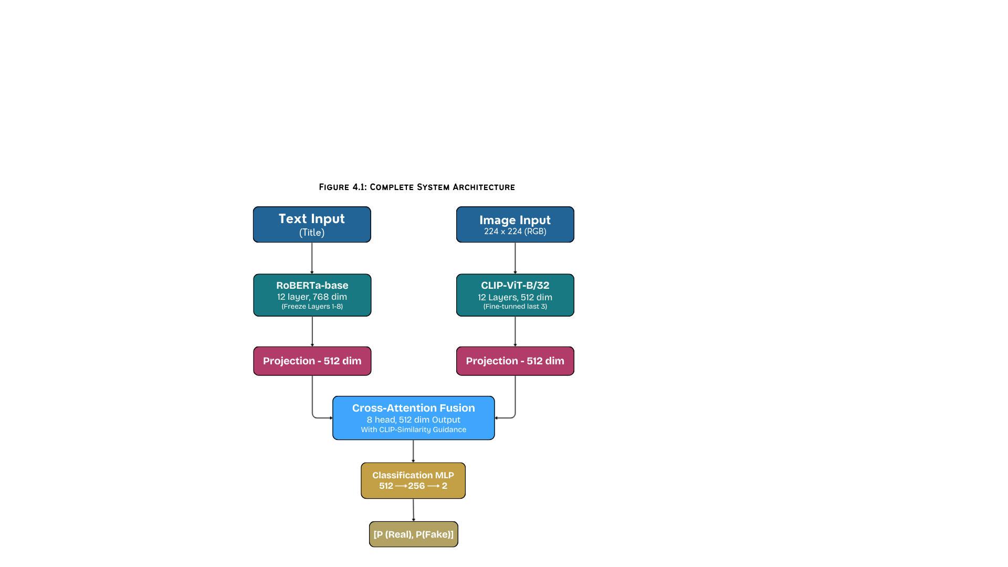
Figure 4.1: System Architecture Diagram

Architecture Components

Text Encoder
The text encoder is implemented in the form of RoBERTa-base (125M parameters) can only handle titles up to 128 tokens. To reduce the training time and prevent disastrous forgetting, the first eight layers are frozen, and the last four are refined only.

Image Encoder
The image encoder uses CLIP ViT-B/32 that uses 32 x 32 patches as opposed to 16 x 16 pixel patches, a decision that can be explained by the fact that it is more computationally efficient as compared to 1632 patches. This encoder had been trained on 400 million image-text pairs. To reduce the computational overhead, the last three transformer blocks are fine-tuned only.

Fusion Model
The fusion module includes an 8-head cross-attention block that acquires text and image modalities relationship learning. All heads of attention are concerned with different semantic patterns, i.e. entity alignment, tonal concordance, and semantic cohesion. The resulting weights of attention provide a first-order account of attention at no extra computational cost.

Processing Pipelines
Figure 4.2, which shows the flow of raw input to the end prediction by the processing stages.
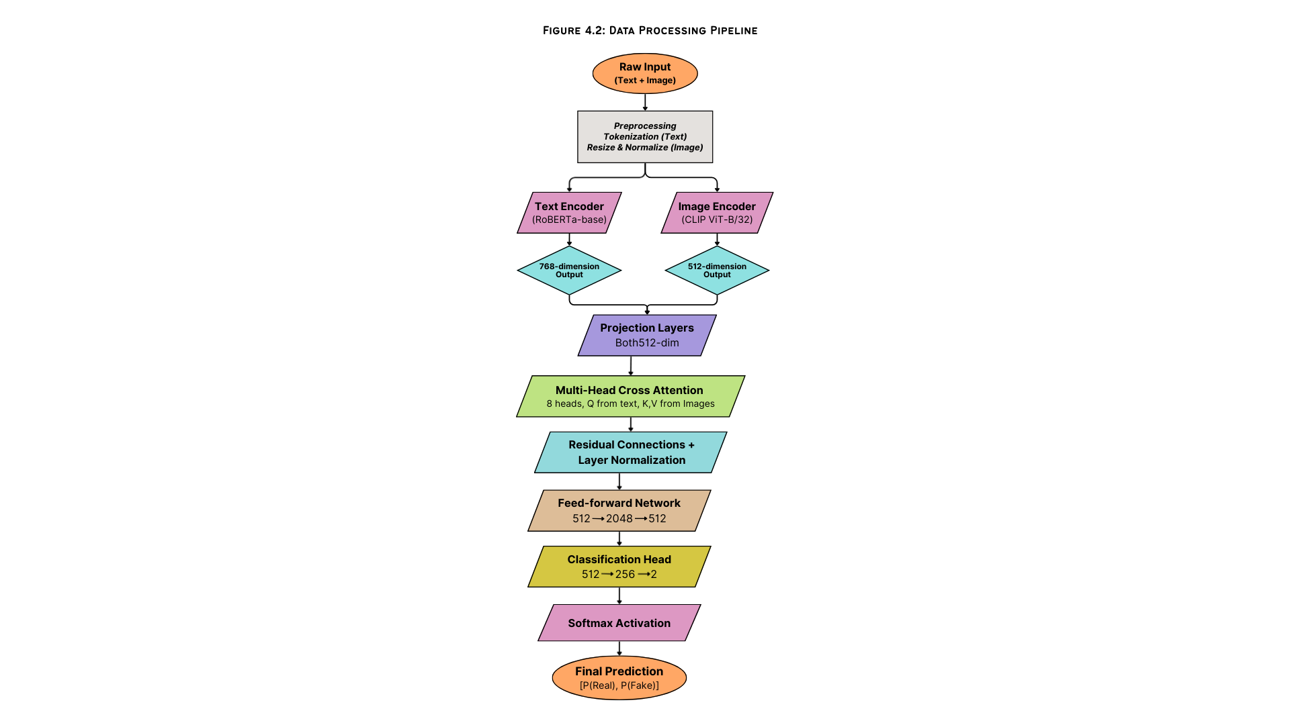
Figure 4.2: Data Processing Pipeline

Core Mathematical Operations

Cross‑Attention Computation:
$$Attention \left(Q,K,V\right)= \left(\frac{QK^{T}}{\sqrt{d_{k}}}\right)$$
Where: Q = text features (K, V) = image features, $d_{k}$ = 64

CLIP Similarity Guidance
$$weighted_fusion = α* attended_features + \left(1-α\right) *text_features$$
Where: $cosine similarity=α=\frac{CLIP_{text}.CLIP_{image}}{\left\|CLIP_{text}\right\|.\left\|CLIP_{image}\right\|}$

Training Loss:
$$L=CrossEntropy \left(predictions, labels\right)$$
With: $label_{smoothing}=0.1$

Explainablility Framework
Another critical aspect of our approach/methodology is a three-tier explainability model that provides insights on the decisions of the model in a manner that is interpretable. This multi-methodology is a combination of intrinsic and post hoc methods, therefore, providing complementary perspectives on the way the model processes multimodal information.
The illustration in figure 4.4 shows the entire explainability pipeline embedded into the system.
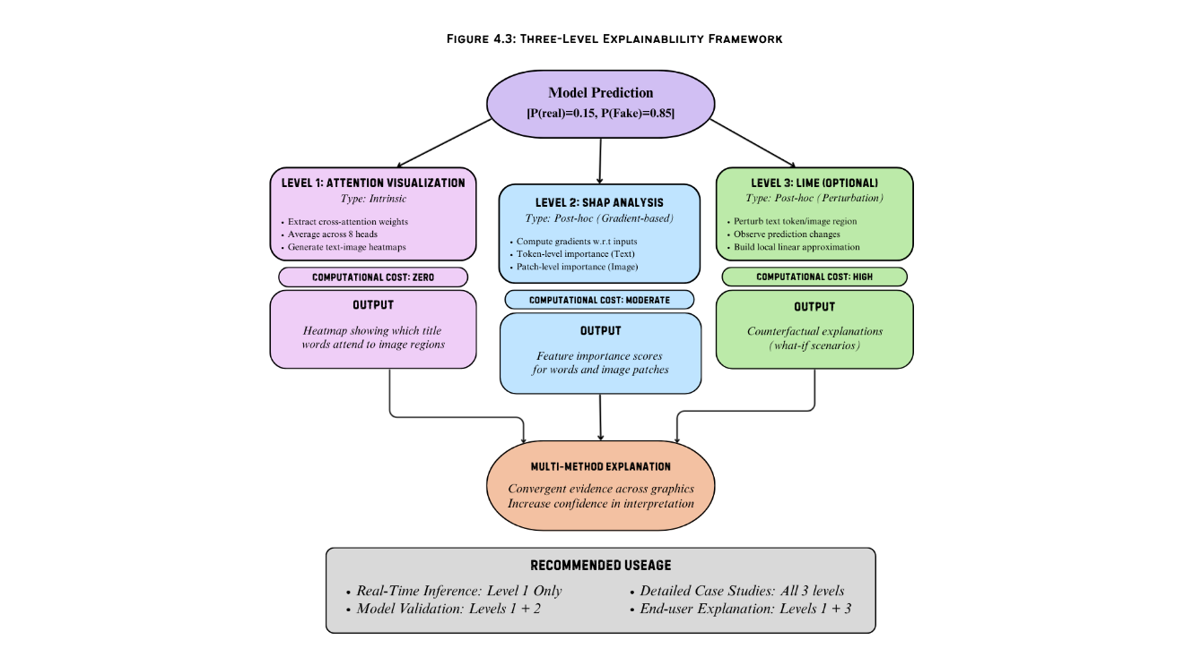
Figure 4.3: Three-level Explainability
Table 2: Level Of Explainability & Interpretation Techniques
Level | Method | Type | Output
1 | Attention Visualization | Intrinsic | Text-image attention heatmaps
2 | SHAP Analysis | Post-hoc | Token and pixel importance scores
3 | LIME (Optional) | Post-hoc | Perturbation-based explanations

Justification for Multimodal Approach
The combination meets a wide range of the stakeholder needs. Attention visualization provides parameter free, instantaneous information during model development. SHAP adds hard and theoretically based explanations of model validation, whereas LIME provides easy to understand explanations that can be used by non-technical users when needed. The methodological redundancy makes the explanations more confident, and makes it easy to determine whether there is a concordance or discordance between the methods.

Limitations and Assumptions

Computational Limitations
Hardware restrictions confine training to a subset of the dataset and hamper hyperparameter optimization. Such difficulties are alleviated by making wise architectural choices such as the use of effective models and freezing of some layers and by using pretrained knowledge in order to bring maximum performance within the limits of available resources.

Dataset Limitations
100K-sample sample might not provide the complete range of misinformation patterns existing on the complete data. In addition, information obtained on Reddit could have platform-specific biases that cannot be extrapolated in other social-media ecosystems. It is optimized on an English text basis; hence, this makes the system worse when used in other languages.

Scope Limitations
The framework is limited to fixed image-text pairs, and thus, it is not applicable to videos and post multi-images. It does not have external fact-checking ability or external knowledge base integration. Furthermore, the binary classification scheme simplifies not only the spectrum of misinformation, but also excludes such subtle types of misinformation as satire or misleading context.

Limitations to Explainability
Attention weights can be used to understand the areas of interest, but they do not necessarily reflect causal factors of the decision-making process. The approximations of SHAP might not be the actual Shapley values and explanations outline model behavior without necessarily implying that the reasoning is accurate.

Methodological Assumptions
The methodology that we use assumes that the tendency in misinformation that is reminiscent of the training data applies to new cases, but this assumption can prove incorrect in the event that misinformation strategies change significantly. We further affirm that there are a relative, but discernible discrepancies in text and image materials in fabricated news, which may in turn be disproven by highly developed deception methods that escape discordant inconsistencies.
The system is restricted to the statical image-text pairs and cannot work with videos or multi-image posts. It is also limited in the transferability of its findings to other languages because it is focused on English-language content. Although the model internalizes the correlations found in the training data, it does not have a real understanding of the content and cannot fact-check the claims with regard to external knowledge sources.
Shortcomings of Explainability Methods Attention weights reveal the focus of the model, but do not identify which features are actually used in decision making. Computational needs of SHAP values are large, and real-time usage may be hindered. Though explanations help human beings to understand how the model behaves, it does not guarantee that the model is acting based on true reasons.
The Fakeddit dataset is assumed to be representative of fake news in a more generalized setting, but the fact that it was based solely on Reddit can be missing patterns of misinformation that are primarily rife in alternative social platforms like Facebook or Twitter. Moreover, binary classification scheme (real vs. fake) is a simplification, which does not reflect the range of misinformation that encompasses satire, misleading material, and even plain fabrications.

Algorithms/Architecture

Novel Contribution

CLIP-Guided Cross-Attention Fusion
Most basic concatenation approaches do not make use of text representations as queries to selectively focus on relevant image regions, which is what our fusion mechanism does. The score of similarity between the CLIPs controlling the fusion weight ensures that the cross-modal feature is not as important when the text and image coherence is low- a possible manipulation signal. This weighted adaptation increases resilience against un-paired text image pairs.

Integrated Three-Level Explainability
Our model is the first to offer the combination of intrinsic (attention) and post-hoc (SHAP, LIME) explainability at different computational expenses. This stratified method allows real-time explanation in the process of inference (attention) and allows a more detailed analysis in the case of necessity (SHAP/LIME). The redundancy in the methodology gives more credence to the accounts.

Resource Efficient Staged Fine-Tunnig
Progressive layer unfreezing trades task adaptation and computational efficiency. Epoch 1 only trains on the projection layers resulting in fast convergence. Epoch 2 releases encoder-layers so that they can be task-specifically tuned. EPOChain 3 and after can be fine-tuned with early stopping and greatly reducing catastrophic forgetting without being computationally unfeasible.
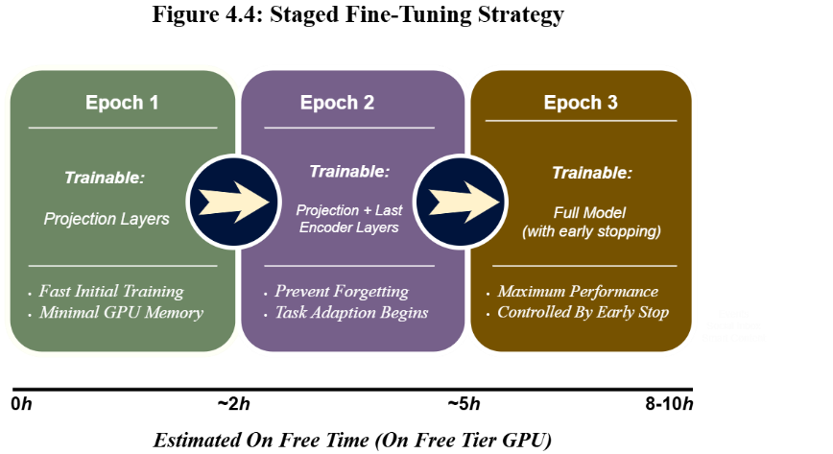
Figure 4.4: Staged Fine-Tuning Strategy

Integration Of Pre-trained Models
Table 3: Model Architecture & Configuration
Component | Model | Configuration
Text Encoder | RoBERTa-base | Max length: 128, Dropout: 0.1, Trainable: layers 9-12
Image Encoder | CLIP Vit-B/32 | Input: 224×224, Patch: 32×32, Trainable: last 3 blocks
Fusion | Cross-Attention | 8 heads, 512-dim, Dropout: 0.1
Classifier | 2-Layer MLP | 512→256→2, ReLU, Dropout: 0.3

Contingency Strategies

Tier 1 (Memory Constraints):
Decrease batch size to eight, increase gradient accumulation to four steps and enable gradient checkpointing in RoBERTa encoder.

Tier 2 (Persistent Memory Problems):
Replace Distil-RoBERTa (66 million parameters vs. 125 million) and reduce the size of the dataset to 50 000 samples maintaining the balance of classes.

Tier 3 (Training Time Constraints):
Apply checkpoint-based training in more than one session, set the longest number of epochs to at most five, and increase the early stopping patience.

Tier 4 (Convergence Difficulties):
Go to a late-fusion architecture - independently train both textual and visual classifiers and combine their predictions - decrease the learning rate to 1 x 10 -5, and the warm-up period to 20 percent of training time.
These contingency plans will ensure that research is completed with normal resource level in academia without affecting the methodological rigor or reproducibility.

Design and Implementation
This chapter outlines the system design, implementation details, tools and environment used and the development life cycle of the HEMT-CLIP: Multimodal Fake News Detection on social media (MFNDSM) system. Chapter 4 includes the architecture and the methodology, which is implemented in the form of a functional prototype with detailed descriptions of every module as well as the integration workflow and the difficulties in the implementation process.

System Design
The system architecture takes a modular design that intersperse concerns into five main sub components namely data preprocessing, text encoding, photo encoding, cross-attention fusion, and explainability generation. The modules are separately testable and can be altered without use of another pipeline. The design is more focused on performance, strength, flexibility and interpretability.

Architecture Design
The methodology proposed uses a cross-attention fusion based on a dual-encoder system as detailed in the system. The architecture on the highest level consists of the following interacting components:

Input layer
Receives a pair composed of text and image of Fakeddit dataset. The text input relates to the post title (up to 128 tokens), whereas the image input is a 224 x 224 RGB image.

Text Encoder Module
It is based on RoBERTa-base (125M parameters) where the first eight layers are frozen and the final four layers are fine-tuned. The encoder gives a 768-dimensional representation, which is then projected to 512 dimensions through a linear projection layer.

Image Encoder Module
Fine-tunes CLIP ViT -B/32, which is pre-trained on 400M image-text pairs, using the final three transformer blocks. The encoder produces a representation of 512-dimension.

Fusion Module
This is a text-to-image cross-attention model employing eight query (Q) and eight key (K) and value (V) vectors. In CLI similarity scores the fusion weights are dynamically modulated based on the weighted fusion formula:
$$W_{fused}= α . F_{attended}+\left(1- α\right) . F_{text}$$
Where: $W_{fused}$ represents weighted fusion output; $α ,\left(1- α\right)$ represents learnable fusion weight; $F_{attended}$ represents attended features; $F_{text}$ represents text features.
In which α represents the similarity with text embedding at the cosine of CLIP image embedding and text embedding.

Classification Head
This has a two-layer MLP (512-256-2) with ReLU activation and dropout (0.3) giving SoftMax probability of the real and fake classes.

Explainability Module
Is a three-level model that offers attention visualization (Level 1), SHAP visualization (Level 2), and optional LIME explanations (Level 3).
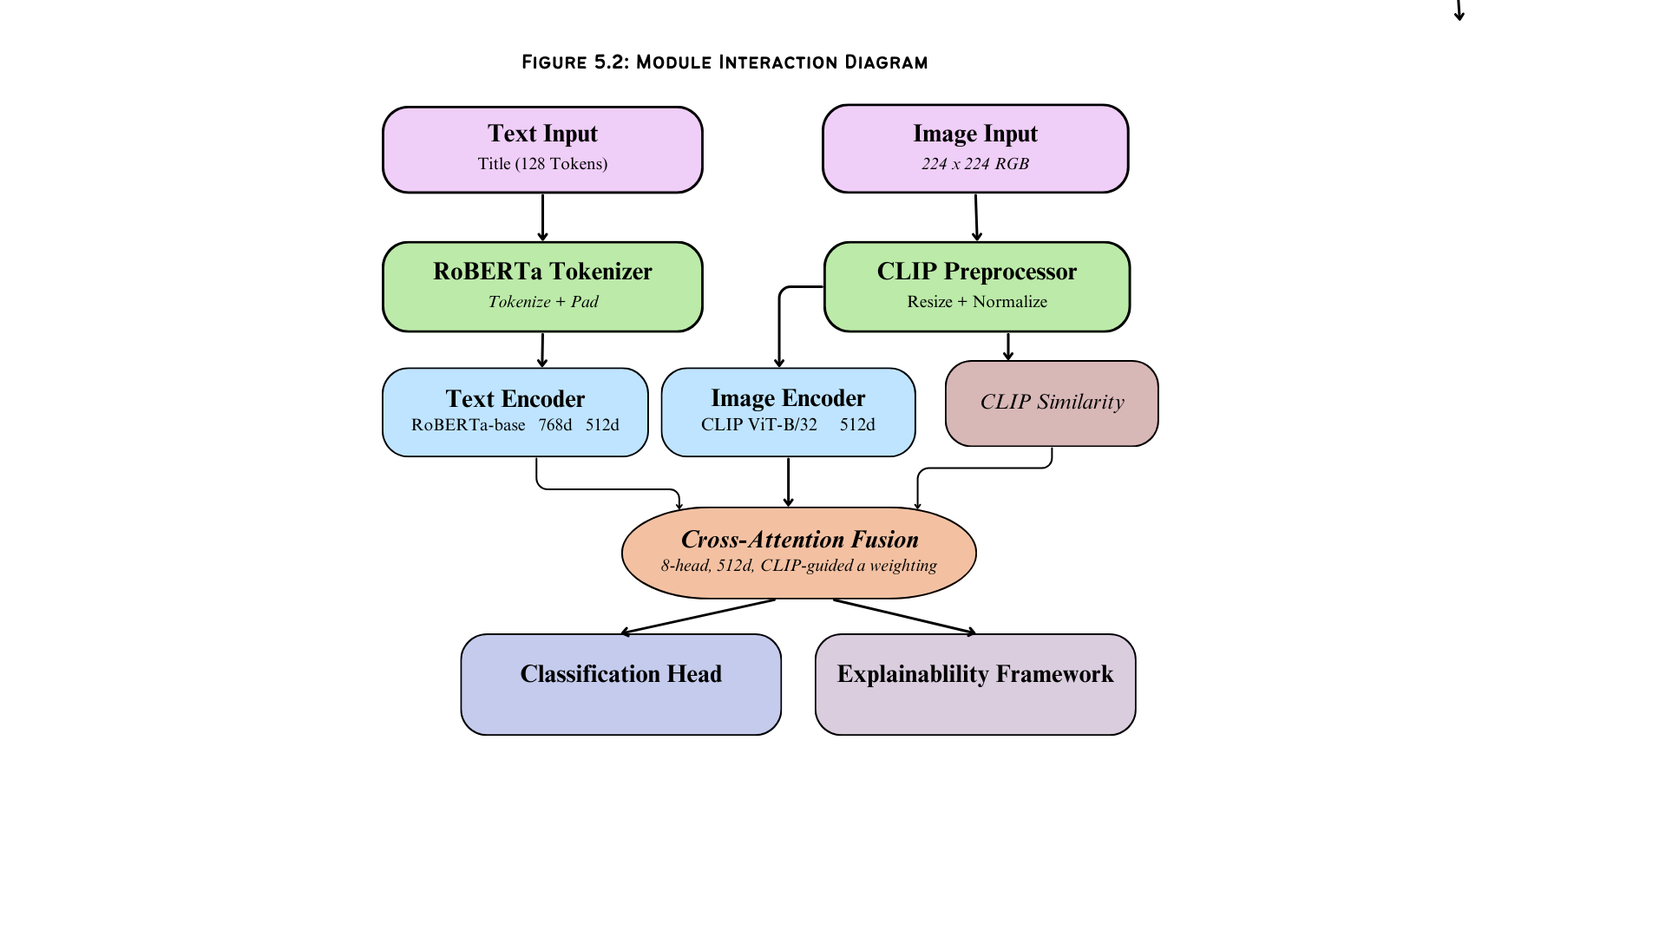
Figure 5.1: Module Interaction Diagram

Interface Design
The system integrates an interactive dashboard (created with Streamlit), where a user can upload news posts (textual and image) and see the results of classification and model explanations. The interface is made up of the following views:

Production View
Prediction View: This is the result of the classification (Real/Fake) and competition scores (confidence) displayed as a probability bar.

Attention Heatmap View
Attention View Heatmap: Visualization of the cross-attention weights in the form of a heatmap, which shows the words in the title that attend to what regions of the image.

SHAP Explanation View
SHAP Explanation View: Visualizes token-level and patch-level scores of importance with gradient-based SHAP which points out the most significant features to the prediction.

LIME Explanation View (Optional)
LIME Explanation View (Optional): Gives counterfactual what-if explanations, pertaining to text tokens and areas of an image and looking at changes in prediction.

System Modeling
The UML diagrams are used to model the system workflow to capture the behavioral and structural characteristics of the system:

Use Case Diagram
It is the diagram that determines actors (End User, Researcher, System Administrator) and their interactions with the system, such as the submission of the news to be analyzed, the predictions and exploration of the explanations as well as the retraining of the model.
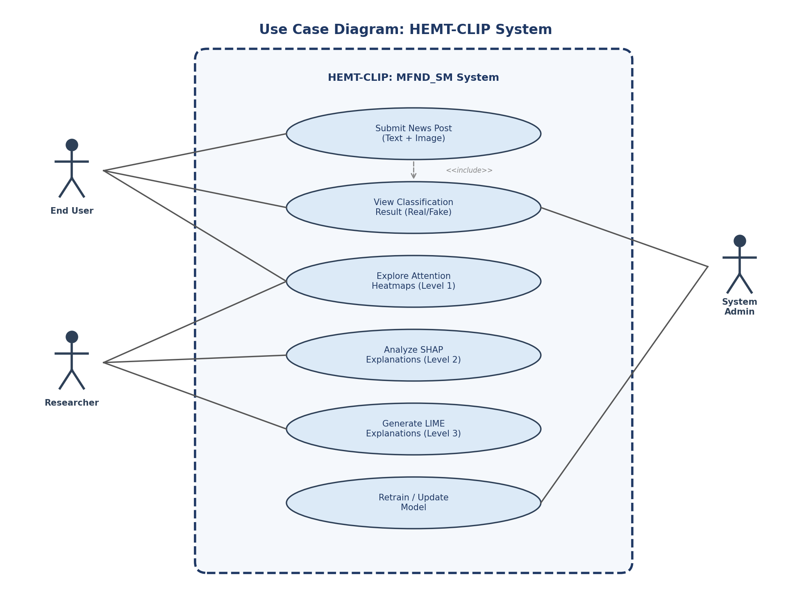
Figure 5.2: Use Case Diagram of HEMT-CLIP System
Activity Diagram
The flow of data between the input of data and preprocessing, dual-encoder feature extraction, cross-attention fusion, classification, and multi-level generation of explanation.
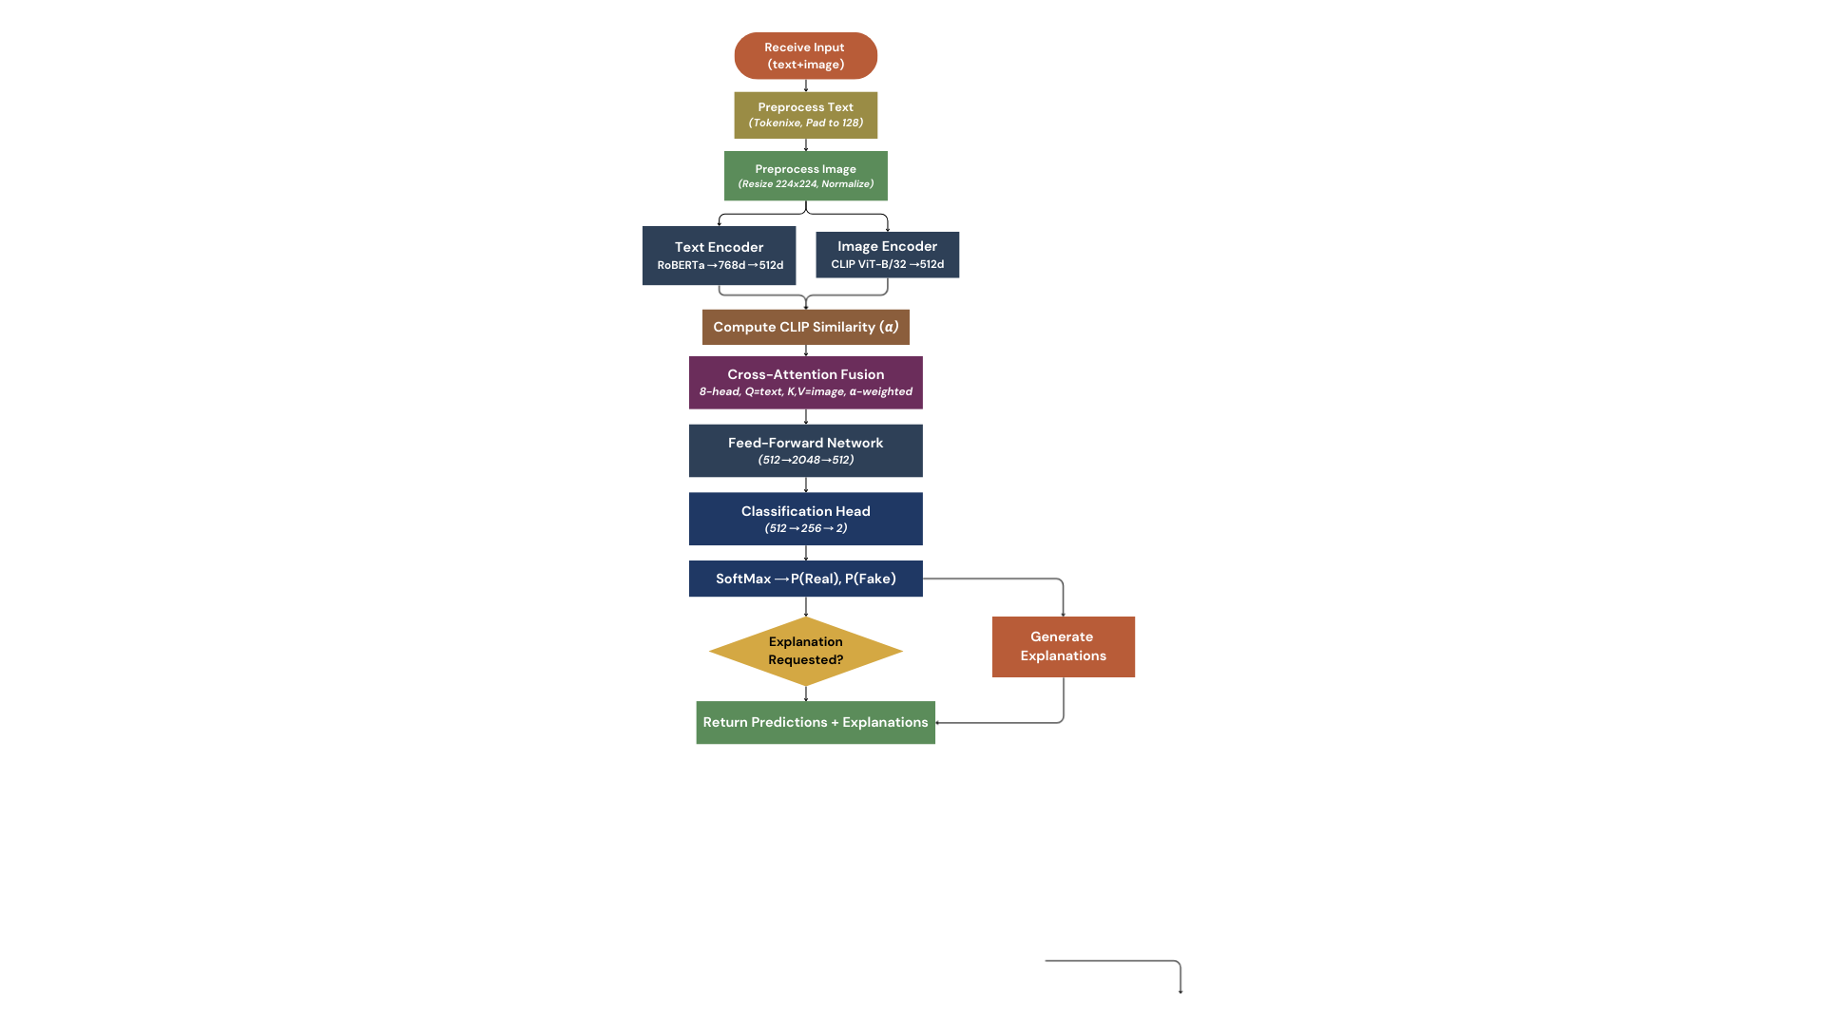
Figure 5.3: Activity Diagram - Prediction Pipeline

Sequence Diagram
Literatures interaction between the StreamLit frontend, preprocessing service, RoBERTa text encoder, CLIP image encoder, fusion module and explainability framework when a single prediction request is made.
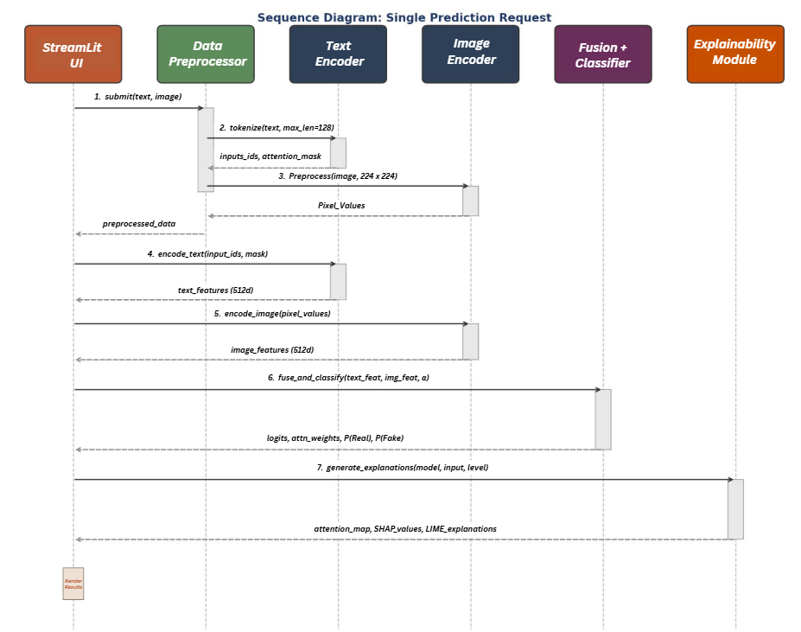
Figure 5.4: Sequence Diagram of Single Prediction Request
Class Diagarm
Class Diagram: It describes major classes such as TextEncoder, ImageEncoder, CrossAttentionFusion, ClassificationHead, SHAPExplainer, LIMEExplainer and DataPreprocessor with their variables and functions.
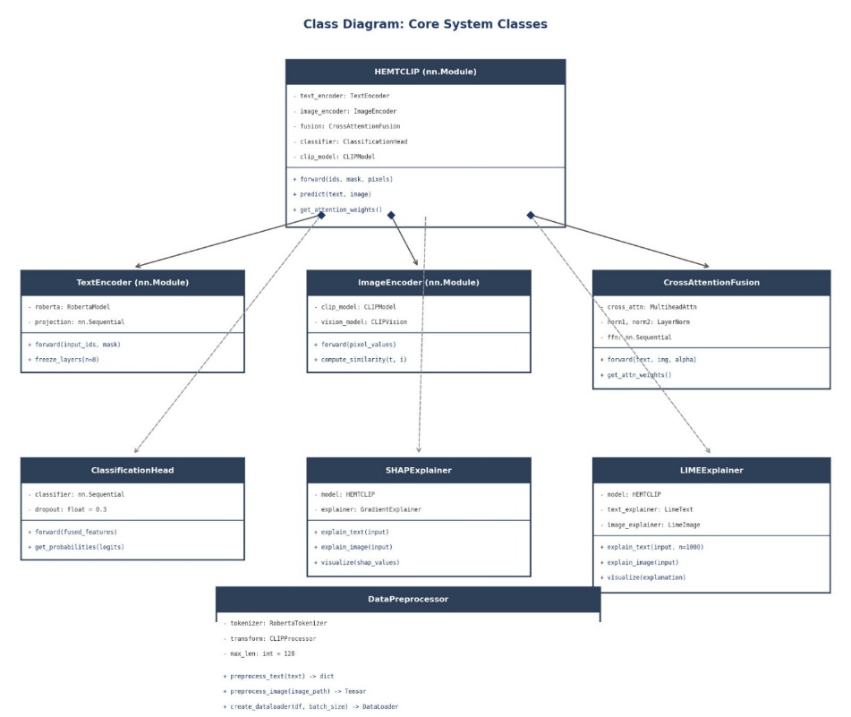
Figure 5.5: Class Diagram of Core System Classes
System Implementation

Development Tools and environments
The development environment was set to support the computational needs of training transformer-based models under the conditions of the academic requirements in resource. Table 4 shows the tools and technologies that were used.

Table 4: Tools and Technologies
Component | Specification
Programming Language | Python 3.10+
DL Framework | PyTorch 2.x with CUDA support
Transformer Library | HuggingFace Transformer 4.x
CLIP Implementation | OpenAI CLIP (via HuggingFace)
XAI Libraries | SHAP 0.43+, LIME 0.2+
Data Processing | Pandas, NumPy, Pillow (PIL), scikit-learn
Visualization | Matplotlib, Seaborn
Web interface | StreamLit
GPU Environment | Google Colab Pro / Kaggle (free-tier GPU: NVIDIA T4 16GB)
Version Control | Git / GitHub
IDE | VS Code, Jupyter Notebook

Implementation Modules
The implementation of the system was done in a modular manner with all components to be developed and tested separately before integrating. Each of the modules is carried out as explained in the following subsections.

Data Preprocessing Module
The data preprocessing module performs the ingestion, cleaning and preparation of the Fakeddit data to train the models. Its implementation follows the following steps:

Dataset loading
Fakeddit dataset is loaded out of the publicly available repository. Each sample contains image URL, a title, a cleaned title and multi-way classification labels. The labels that are retained in this project include 2-way labels (0 = real, 1 = fake).

Image Acquisition
Images are downloaded from the given URLs and ends up storing them locally in 224 x 224 RGB JPEG files. Images that are missing or corrupted are logged and excluded during the process of training. The CLIP preprocessing pipeline (mean = [0.48145466, 0.4578275, 0.40821073], std = [0.26862954, 0.26130258, 0.27577711]) is used to normalize images.

Text Preprocessing
The title field has been cleaned and tokenized with RoBERTa tokenizer with a sequence length of 128 tokens. Padding and truncation are applied to ensure uniform input dimensions. The tokenizer will automatically add special tokens ([CLS], [SEP]).

Data Splitting
The data is divided into training (70%), validation (15%) and test (15%) and stratified through sampling to ensure that all splits have equal classes. The division is done using a fixed random seed (seed= 42) to ensure reproducibility.

DataLoader Configuration:
Batches size of DataLoader objects is set to 16 (changeable under contingency Tier 1), shuffle is turned on during training and pin_memory is turned on to achieve efficiency in transferring data to the GPU. The matching of tokenized text, processed images and labels is done by a custom collate function.
Sample Code for custom dataset class:
class FakedditDataset(Dataset):
def __init__(self, dataframe, tokenizer, transform, max_len=128):
self.data = dataframe
self.tokenizer = tokenizer
self.transform = transform
self.max_len = max_len

def __getitem__(self, idx):
row = self.data.iloc[idx]
text = row['clean_title']
encoding = self.tokenizer(text, max_length=self.max_len,
padding='max_length', truncation=True,
return_tensors='pt')
image = Image.open(row['image_path']).convert('RGB')
image = self.transform(image)
label = torch.tensor(row['2_way_label'], dtype=torch.long)
return encoding, image, label

Text Encoder Module
The text encoder is developed based on an architecture called HuggingFace Transformers, which is the RoBERTa-base. The implementation will involve the following important aspects:

Model Initialization
AutoModel.from_pretrained (RoBERTa-base) loads the pretrained RoBERTa -base model. This model has 12 layers of transformers with 768-hidden dimensions.

Strategy Layer Freezing
Layers 0 to 7 (the initial 8 layers) are frozen by setting requires_grad=False on their parameters. This is to preserve the overall/general linguistic information acquired during the pretraining process but permits the layers 8 – 11 to fit the fake news detection problem. Embedding layer is also frozen.

Projection Layer
This layer is a linear projection layer (768→512) with LayerNorm and dropout (0.1) which maps the RoBERTa output to a 512-dimensional space compatible with the CLIP image embeddings for fusion.
Sample Code for text-encoder:
class TextEncoder(nn.Module):
def __init__(self):
super().__init__()
self.roberta = RobertaModel.from_pretrained('roberta-base')
# Freeze first 8 layers
for param in self.roberta.embeddings.parameters():
param.requires_grad = False
for i in range(8):
for param in self.roberta.encoder.layer[i].parameters():
param.requires_grad = False
self.projection = nn.Sequential(
nn.Linear(768, 512), nn.LayerNorm(512), nn.Dropout(0.1))

def forward(self, input_ids, attention_mask):
outputs = self.roberta(input_ids, attention_mask)
cls_output = outputs.last_hidden_state[:, 0, :]
return self.projection(cls_output)

Image Encoder Module
The image encoder leverages CLIP ViT -B/32 vision transformer, which is pre-trained on 400 million image-text pairs. The following are the details of implementation:

Model Initialization
CLIP ViT -B/32 model is loaded via OpenAI CLIP package or the Hugging-Face version. The vision encoder takes 224 x 224 images and breaks them down to 32 x 32 patches (resulting in 49 patch tokens with an additional [CLS] token) and generates an output with 512-dimensions.

Fine-Tuning Strategy
Fine-tuning of only the last 3 unfrozen blocks (out of 12) of the transformers takes place. The position embedding layer, patch embedding layer and all the previous layers are frozen. This reduces the computation load and provides task-specific adaptation.

Computation of CLIP Similarity
The CLIP encoder is also a feature of computing text-image cosine similarity with the entire CLIP model (the text and vision encoders). The fusion module is then used to dynamically weight the cross-modal features based on this similarity score (α).
Sample code for image encoder:
class ImageEncoder(nn.Module):
def __init__(self):
super().__init__()
self.clip_model = CLIPModel.from_pretrained(
'openai/clip-vit-base-patch32')
# Freeze all except last 3 vision transformer blocks
for param in self.clip_model.vision_model.parameters():
param.requires_grad = False
for block in self.clip_model.vision_model.encoder.layers[-3:]:
for param in block.parameters():
param.requires_grad = True

def forward(self, pixel_values):
vision_out = self.clip_model.vision_model(pixel_values)
return vision_out.pooler_output # 512-dim

Cross-Attention Fusion Module
The hybridizing module that is core novel contribution to the HEMT-CLIP is the cross-attention fusion. It implements a CLIP-guided cross-attention mechanism which dynamically fuses both the textual and visual features depending on their alignment in semantics.

Multi-Head Cross-Attention
8-head attention is implemented, using nn.MultiheadAttention (embed_dim=512, num_heads=8, dropout=0.1, batch_first=True). The features of a text are queries (Q), the features of an image are keys (K), and the values (V). Each attention heads (d_k=64) captures different semantic patterns including entity alignment, tonal concordance, and semantic cohesion.

CLIP Similarity Guidance
CLIP text and image embeddings are used to calculate the cosine similarity between the image and text of every sample in the batch. The fusion is of this nature (i.e. a): in the case of semantic alignment between text and image (a is large), the cross-attended features are more heavily weighted; in the case of low alignment (a potential manipulated signal), the model tends to utilize text features only.

Residual Connections and Layer normalization
The fusion module also has residual connections and layer normalization following the cross -attention operation, then an additional feed-forward network (512→2048→512) with GELU activation and dropout.
Sample code for the fusion module:
class CrossAttentionFusion(nn.Module):
def __init__(self, dim=512, heads=8, dropout=0.1):
super().__init__()
self.cross_attn = nn.MultiheadAttention(
embed_dim=dim, num_heads=heads,
dropout=dropout, batch_first=True)
self.norm1 = nn.LayerNorm(dim)
self.ffn = nn.Sequential(
nn.Linear(dim, 2048), nn.GELU(),
nn.Dropout(dropout), nn.Linear(2048, dim))
self.norm2 = nn.LayerNorm(dim)

def forward(self, text_feat, img_feat, alpha):
# Cross-attention: Q=text, K=V=image
attended, attn_weights = self.cross_attn(
text_feat, img_feat, img_feat)
attended = self.norm1(text_feat + attended)
# CLIP-guided weighted fusion
fused = alpha * attended + (1 - alpha) * text_feat
fused = self.norm2(fused + self.ffn(fused))
return fused, attn_weights

Classification Head
The classification head converts the fused multimodal representation to categorical decision that is binary. It is implemented as a 2-layer MLP (multilayer perceptron) and its configuration is 512→256→2 with the activation on the dropout being ReLU between connected layers and a dropout rate of 0.3 for regularization. A SoftMax function is applied to the terminal output and provides the probabilities of the classes P (Real) and P (Fake). Cross-entropy loss is minimized to train the model which is supplemented with a label-smoothing factor of 0.1 to improve the generalization ability.
Sample code for classification head:
class ClassificationHead(nn.Module):
def __init__(self, input_dim=512, hidden_dim=256, num_classes=2):
super().__init__()
self.classifier = nn.Sequential(
nn.Linear(input_dim, hidden_dim),
nn.ReLU(),
nn.Dropout(0.3),
nn.Linear(hidden_dim, num_classes))

def forward(self, x):
return self.classifier(x)

Explainablility Framework Implementation
The presented explainability framework includes three levels of hierarchy and is embodied into a separate module, which can be enabled with different computational costs, depending upon the use-case.

Leve l – Attention Visualization (Intrinsic, Zero Cost)
Cross-attention weights of 8-head attention sub-module are obtained during the forward pass. These weights are average in all the 8-heads to create a single attention map that shows the mapping of correspondence between title tokens and image areas. The map has been drawn in the form of a heatmap using Matplotlib and overlaid on the original image. This level does not have any additional computational costs beyond the standard forward pass.

Level 2 – SHAP Analysis (Post-hoc, Gradient-Based, Moderate Cost)
SHAP Gradient-based implementation is provided through GradientExplainer of SHAP library. In textual inputs, SHAP does the computation of token-level importance by estimating the gradient of the model output, with respect to each embedding of the token. When image-based inputs are used, SHAP would identify patch-level importance by estimating the gradient with regards to each image patch. Textual tokens are represented as bar charts and image patches as heatmap overlays of visualized derived importance scores.

Level 3 – LIME Explanations (Post-hoc, Perturbation based, High Cost)
LIME is applied as an optional module that uses the lime package. Textually, LIME does perturbations by masking individual tokens and observing the resultant changes in predictions, constructing a local linear approximation model to explain the reasoning of the model on the particular input example. In the visual domain, LIME segments the image into super-pixels using the Quick-shift algorithm and alters these parts to isolate the most powerful parts. This level is not suitable to real-time inference and is suggested to use it in in-depth case studies because it is computationally intensive.

Training procedures
The training program is based on the staged fine-tuning program described in the methodology and implemented with the following configuration:
Table 5: Training Hyperparameters and Configuration
Parameter | Value
Optimizer | AdamW (weight_decay = 0.01)
Learning Rate | 2 x 10⁻⁵ (with linear warmup for 10% of training steps)
Batch size | 16 (adjustable to 8 under Tier 1 contingency
Epochs | 3 – 5 (with early stopping)
Label Smoothing | 0.1
Gradient Accumulation | 1 step (4 steps under Tier 1 contingency)
Early Stopping | Patience = 3 (monitored every 500 steps on validation loss)
Training Data Subset | 100K samples (stratified from full Fakeddit corpus)
Mixed Precision | FP16 via torch.cuda.amp for memory efficiency

The staged fine-tuning process is outlined in the following manner:

Epoch 1 (≈2 hours)
Only the projection layers and the classification head are the only unfrozen layers to be optimized, and all the encoder layers are frozen. It is the first stage that fastens the convergence with minimal GPU memory consumptions.

Epoch 2 (≈3 hours)
The last four RoBERTa layers as well as the last 3 CLIP ViT blocks are also unfrozen alongside the projection and classification layers. This middle stage is the beginning of task-specific adaptation and protection against the catastrophic loss of pre-trained knowledge.

Epoch 3+ (≈3 – 5 hours)
the full model is released to be trained, while early stopping is actively monitored. The learning-rate scheduler gradually reduces the rate as the training progresses and the training is terminated when the validation loss cannot reduce any further after three consecutive evaluation cycles.
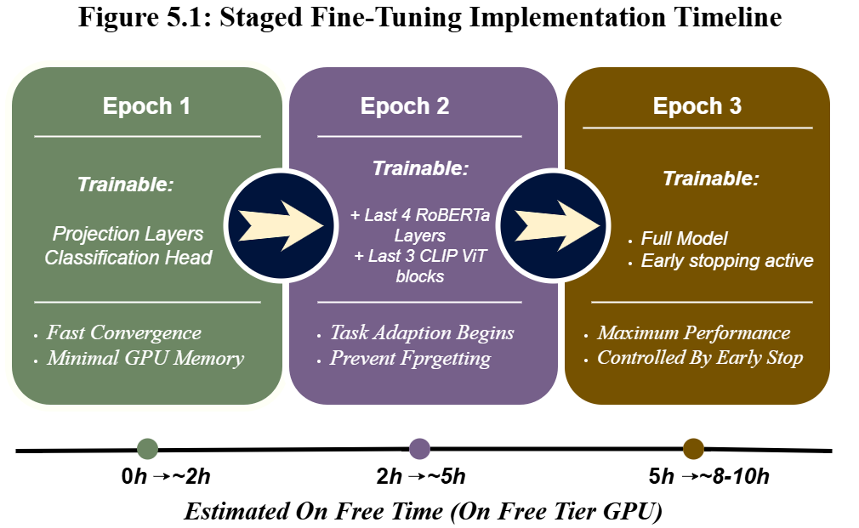
Figure 5.6: Staged Fine-Tuning Implementation Timeline

Full-Model Integration
The complete HEMT-CLIP model integrates all modules into a single forward pass:
class HEMTCLIP(nn.Module):
def __init__(self):
super().__init__()
self.text_encoder = TextEncoder()
self.image_encoder = ImageEncoder()
self.fusion = CrossAttentionFusion()
self.classifier = ClassificationHead()
self.clip_model = CLIPModel.from_pretrained(
'openai/clip-vit-base-patch32')

def forward(self, input_ids, attention_mask, pixel_values):
text_feat = self.text_encoder(input_ids, attention_mask)
img_feat = self.image_encoder(pixel_values)
# Compute CLIP similarity for fusion guidance
with torch.no_grad():
clip_out = self.clip_model(input_ids, pixel_values)
alpha = F.cosine_similarity(
clip_out.text_embeds, clip_out.image_embeds)
alpha = alpha.unsqueeze(-1)
fused, attn_weights = self.fusion(
text_feat.unsqueeze(1), img_feat.unsqueeze(1), alpha)
logits = self.classifier(fused.squeeze(1))
return logits, attn_weights, alpha

Coding Standards and Conventions
The project is based on the consistent coding standards in order to ensure maintainability and reproducibility:

Naming Conventions
Classes use PascalCase (e.g. TextEncoder, CrossAttentionFusion); Functions and variables use snake_case (e.g. compute_shap_values, attention weights); constants are defined in UPPER_SNAKE_CASE (e.g. MAX_SEQ_LENGTH, BATCH_SIZE).

Project Structure
Each of them has its own sub-directory within the codebase: src/models/ (encoders, fusion, classifiers modules), src/data/ (dataset classes, preprocessing), src/explainability/ (SHAP, LIME, attention visualisation), src/training/ (training loops, schedulers), src/utils/ (logging, metrics, helpers), and app/ (Streamlit interface).

Documentation
Every class and function contain docstrings that are well formatted according to the Google style guide. Setup instructions, usage examples, and configuration details are provided in a README.md file.

Reproducibility
All of these random seeds are fixed (seed = 42 for Python, NumPy, PyTorch, and CUDA). At the end of every epoch model checkpoints are saved, and training metadata is saved to be used in tracking systematic experiments.

Difficulties Faced and Solutions
Various difficulties were also experienced in the implementation phase. The main challenges and the mitigation measures that have been implemented are summarized in the table below:
Implementation Difficulties and Solutions Table 6.
Table 6: Implementation's Difficulties & Solutions
Difficulty | Impact | Solution
GPU Memory Limitations | Out Of Memory Limitations When training a batch size of 16 on free-tier GPUs | Applied Tier 1 contingency:  Reduced batch-size to 8, enabled gradient accumulation (4 steps), and activated FP16 mixed precision training
Missing/Corrupted Images | Approx. 5 – 8% of Fakeddit image URLs were broken or returned corrupted files | Implemented a robust image loading pipeline with try-except blocks, fallback to a placeholder image (224 x 224 black), and loading of missing samples for exclusion
Dimension Mismatch | RoBERTa (768-dim) & CLIP ViT-B/32 (512-dim) produces different embedding sizes | Implemented linear projection layers to map both representations to a common 512-dimensional space before fusion
SHAP Computation Time | GradientExplainer required significant time per sample, making batch-level analysis slow | Limited SHAP analysis to a random subset of 100 test samples for evaluation, used Level 1(attention) for real-time inference
Catastrophic Forgetting | Early experiments with full model fine-tunning from the start led to degraded performance on general language understanding | Adopted the staged fine-tuning strategy with progressive layer unfreezing, which preserved pre-trained knowledge while allowing task adaption
LIME Instability | LIME produced inconsistent explanations across multiple runs to random perturbation sampling | Fixed the random seed for LIME perturbations and increase the number of perturbation samples to 1000 for more stable local approximations.

Assumptions/Constraints

Assumptions
Implementation is based on the following assumptions: The Fakeddit dataset is reflective of social media patterns of misinformation more broadly; text-image pairs found in fake news exhibit detectable semantic discrepancies; the knowledge state of pretrained RoBERTa and CLIP ViTB/32 can be transfers effectively to the fake-news detecting domain; the language in which the misinformation is detected is predominantly English; and the binary classification problem (real vs. fake) is sufficiently large to behave as an evaluation problem.

Constraints
Implementation is constrained by the following factors: training is constrained to free-tier or low-cost GPU environments (NVIDIA T4 16 GB) which limits both batch size and amount of parameters to be trained; dataset size is restricted to 100,000 samples because of storage and computational constraints; the system only accepts pairs of images and texts (no video, audio or multi-image posts) and the explainability system (especially Levels 2 and 3) is computationally expensive, preventing it to handle all levels of explanation in real-time; and the system does not integrate external knowledge or fact-checking APIs, limiting its ability to verify factual claims independently.

Evaluation Metrics
The system is measured in terms of classification performance and quality explainability. The metrics of classification include accuracy, precision, recall, F1-score, and AUC-ROC. Explainability is measured by qualitative analysis of attention heatmap, the consistency of SHAP feature importance between available indicators of misinformation, and consensus across the three levels of explanation (convergent evidence). The proposed evaluation will be conducted through a user study to determine the usefulness and credibility of the generated explanations.

References/ Bibliography
[1] K. Shu, L. Cui, S. Wang, D. Lee, and H. Liu, “Defend: Explainable fake news detection,” in Proceedings of the ACM SIGKDD International Conference on Knowledge Discovery and Data Mining, Association for Computing Machinery, Jul. 2019, pp. 395–405. doi: 10.1145/3292500.3330935.
[2] A. Giachanou, G. Zhang, and P. Rosso, “Multimodal Multi-image Fake News Detection.” [Online]. Available: https://www.tensorflow.org/hub
[3] Y. Zhou, Q. Ying, Z. Qian, S. Li, and X. Zhang, “Multimodal Fake News Detection via CLIP-Guided Learning,” May 2022, [Online]. Available: http://arxiv.org/abs/2205.14304
[4] M. I. Nadeem et al., “SSM: Stylometric and semantic similarity oriented multimodal fake news detection,” Journal of King Saud University - Computer and Information Sciences, vol. 35, no. 5, May 2023, doi: 10.1016/j.jksuci.2023.101559.
[5] T. Ohkawa, H. Yoshiura, and T. Yamaguchi, “Explainable Multimodal Fake Posts Detection Using Feature Extraction with Attention Mechanisms,” in Proceedings - 2023 IEEE 23rd International Conference on Software Quality, Reliability, and Security Companion, QRS-C 2023, Institute of Electrical and Electronics Engineers Inc., 2023, pp. 555–563. doi: 10.1109/QRS-C60940.2023.00068.
[6] G. Joshi et al., “Explainable Misinformation Detection Across Multiple Social Media Platforms,” IEEE Access, vol. 11, pp. 23634–23646, 2023, doi: 10.1109/ACCESS.2023.3251892.
[7] S. Amri, H.-C. M. Boleilanga, and E. Aïmeur, “ExFake: Towards an Explainable Fake News Detection Based on Content and Social Context Information,” Nov. 2023, [Online]. Available: http://arxiv.org/abs/2311.10784
[8] H. Liu, W. Wang, H. Li, and H. Li, “TELLER: A Trustworthy Framework for Explainable, Generalizable and Controllable Fake News Detection,” May 2024, [Online]. Available: http://arxiv.org/abs/2402.07776
[9] A. Hashim Jawad Almarashy, M. R. Feizi-Derakhshi, and P. Salehpour, “Elevating Fake News Detection Through Deep Neural Networks, Encoding Fused Multi-Modal Features,” IEEE Access, vol. 12, pp. 82146–82155, 2024, doi: 10.1109/ACCESS.2024.3411926.
[10] S. El-Amrany, M. R. Brust, J. E. Pecero, and P. Bouvry, “Tri-FusionDet: Leveraging User Engagement, Textual, and Visual Features for Enhanced Fake News Detection,” in International Computer Science and Engineering Conference, Institute of Electrical and Electronics Engineers Inc., 2024. doi: 10.1109/ICSEC62781.2024.10770746.
[11] Y. Liu, W. Bing, S. Ren, and H. Ma, “BC-FND: An Approach Based on Hierarchical Bilinear Fusion and Multimodal Consistency for Fake News Detection,” IEEE Access, vol. 12, pp. 62738–62749, 2024, doi: 10.1109/ACCESS.2024.3392409.
[12] A. Sormeily, S. Dadkhah, X. Zhang, and A. A. Ghorbani, “MEFaND: A Multimodel Framework for Early Fake News Detection,” IEEE Trans. Comput. Soc. Syst., vol. 11, no. 4, pp. 5337–5353, 2024, doi: 10.1109/TCSS.2024.3355300.
[13] S. Safdar and M. Wasim, “RAFAH: RoBERTa Fine-Tuned Model and a Hybrid Features Set for Fake News Detection,” in 2024 18th International Conference on Open Source Systems and Technologies, ICOSST 2024 - Proceedings, Institute of Electrical and Electronics Engineers Inc., 2024. doi: 10.1109/ICOSST64562.2024.10871139.
[14] F. Khan, R. Alturki, G. Srivastava, F. Gazzawe, S. T. U. Shah, and S. Mastorakis, “Explainable Detection of Fake News on Social Media Using Pyramidal Co-Attention Network,” IEEE Trans. Comput. Soc. Syst., vol. 11, no. 4, pp. 4574–4583, 2024, doi: 10.1109/TCSS.2022.3207993.
[15] S. Safdar and M. Wasim, “DFN-SCNC: Detecting Fake News based on Social Context and News Content: A Hybrid Approach using BERT and Bi-GRU,” in 2024 International Conference on Frontiers of Information Technology, FIT 2024, Institute of Electrical and Electronics Engineers Inc., 2024. doi: 10.1109/FIT63703.2024.10838445.
[16] T. A. Roshinta and S. Gábor, “A Comparative Study of LIME and SHAP for Enhancing Trustworthiness and Efficiency in Explainable AI Systems,” in 2024 IEEE International Conference on Computing, ICOCO 2024, Institute of Electrical and Electronics Engineers Inc., 2024, pp. 134–139. doi: 10.1109/ICOCO62848.2024.10928183.
[17] J. Wang, Z. Zhu, C. Liu, R. Li, and X. Wu, “LLM-Enhanced multimodal detection of fake news,” PLoS One, vol. 19, no. 10 October, Oct. 2024, doi: 10.1371/journal.pone.0312240.
[18] F. Yan, M. Zhang, B. Wei, K. Ren, and W. Jiang, “FMC: Multimodal fake news detection based on multi-granularity feature fusion and contrastive learning,” Alexandria Engineering Journal, vol. 109, pp. 376–393, Dec. 2024, doi: 10.1016/j.aej.2024.08.103.
[19] R. Kozik et al., “Towards explainable fake news detection and automated content credibility assessment: Polish internet and digital media use-case,” Neurocomputing, vol. 608, Dec. 2024, doi: 10.1016/j.neucom.2024.128450.
[20] O. V. Likha, S. S. Kumar, N. Mohan, and O. K. Sikha, “Fake News and Offensive Content Detection in Malayalam Using Machine Learning, Deep Learning, and Transformer Based Methods With XAI,” IEEE Access, vol. 13, pp. 186633–186664, 2025, doi: 10.1109/ACCESS.2025.3623172.
[21] B. Liu, “Research on Natural Language Misleading Content Detection Method Based on Attention Mechanism,” IEEE Access, vol. 13, pp. 132410–132425, 2025, doi: 10.1109/ACCESS.2025.3591455.
[22] L. Yang, J. Zhang, and X. Wang, “GAConF: A Multimodal Fake News Detection Framework Fusing Gated Attention and Category Perception Losses,” in 2025 4th International Symposium on Robotics, Artificial Intelligence and Information Engineering, RAIIE 2025, Institute of Electrical and Electronics Engineers Inc., 2025, pp. 389–393. doi: 10.1109/RAIIE65740.2025.11140561.
[23] E. Choi, J. Ahn, X. Piao, and J. K. Kim, “CroMe: Multimodal Fake News Detection Using Cross-Modal Tri-Transformer and Metric Learning,” IEEE Access, vol. 13, pp. 197124–197132, 2025, doi: 10.1109/ACCESS.2025.3633841.
[24] P. Du, Y. Gao, L. Li, and X. Li, “SGAMF: Sparse Gated Attention-Based Multimodal Fusion Method for Fake News Detection,” IEEE Trans. Big Data, vol. 11, no. 2, pp. 540–552, 2025, doi: 10.1109/TBDATA.2024.3414341.
[25] K. Tian, G. Rao, X. Wang, M. Yu, J. Zhang, and L. Zhang, “CMFNThinker: A Novel Cross-source Multi-modal Fake News Detection Model,” in ICASSP, IEEE International Conference on Acoustics, Speech and Signal Processing - Proceedings, Institute of Electrical and Electronics Engineers Inc., 2025. doi: 10.1109/ICASSP49660.2025.10889602.
[26] Y. Wang, B. Wei, M. Zhang, and F. Yan, “FND-MC: Fake News Detection Based on Crossmodal Alignment and Multimodal Fusion,” in 2025 International Conference on Artificial Intelligence and Engineering Management, ICAIEM 2025, Institute of Electrical and Electronics Engineers Inc., 2025, pp. 5–10. doi: 10.1109/ICAIEM66060.2025.11139161.
[27] K. Irfan, M. Wasim, S. Safdar, A. Rehman, and M. U. Ghani, “XFND: Explainable Fake News Detection using a Hybrid DistillBERT and BiLSTM,” in 2nd International Conference on Emerging Technologies in Electronics, Computing and Communication, ICETECC 2025, Institute of Electrical and Electronics Engineers Inc., 2025. doi: 10.1109/ICETECC65365.2025.11070272.
[28] S. Hameed and M. Wasim, “Interpretable BERT and RoBERTa based Fake News Detection using LIME,” in International Conference on Innovation in Artificial Intelligence and Internet of Things, AIIT 2025, Institute of Electrical and Electronics Engineers Inc., 2025. doi: 10.1109/AIIT63112.2025.11082880.
[29] N. Iftikhar and M. Wasim, “BERT-BiLSTM: A Novel Hybrid Approach for Stance Detection on Political Tweets,” in 2nd International Conference on Emerging Technologies in Electronics, Computing and Communication, ICETECC 2025, Institute of Electrical and Electronics Engineers Inc., 2025. doi: 10.1109/ICETECC65365.2025.11071115.
[30] A. Seerat and M. Wasim, “Leveraging Dual GNNs and BERT for Context-Aware Rumor Detection in Social Networks,” in International Conference on Innovation in Artificial Intelligence and Internet of Things, AIIT 2025, Institute of Electrical and Electronics Engineers Inc., 2025. doi: 10.1109/AIIT63112.2025.11082865.
[31] S. Nasir, M. Wasim, A. Rehman, and M. U. Ghani, “FACT-CLIP: Fake News Detection via CLIP-Based Cross-Modal Attention and Transformer Fusion,” in 2nd International Conference on Emerging Technologies in Electronics, Computing and Communication, ICETECC 2025, Institute of Electrical and Electronics Engineers Inc., 2025. doi: 10.1109/ICETECC65365.2025.11070224.
[32] K. Srinarayani, K. Rajpopat, K. Patel, and N. Chaudhari, “Explainable Fake News Detection with Source Credibility and Decision Transparency,” in 2025 2nd International Conference on Computing and Data Science, ICCDS 2025, Institute of Electrical and Electronics Engineers Inc., 2025. doi: 10.1109/ICCDS64403.2025.11209129.
[33] H. Yu, H. Wu, X. Fang, M. Li, and H. Zhang, “SR-CIBN: Semantic relationship-based consistency and inconsistency balancing network for multimodal fake news detection,” Neurocomputing, vol. 635, Jun. 2025, doi: 10.1016/j.neucom.2025.129997.
[34] T. M. H. Gedara, R. Gaeta, S. Tomasiello, and R. El Shawi, “Toward Explainable Multimodal Fake News Detection: A Fusion of Prompt Learning and Automated Machine Learning,” IEEE Access, vol. 13, pp. 188150–188169, Oct. 2025, doi: 10.1109/ACCESS.2025.3627504.
[35] R. Jadhav, V. Meshram, A. Bhosle, K. Patil, S. Dash, and S. Jadhav, “Explainable multilingual and multimodal fake-news detection: toward robust and trustworthy AI for combating misinformation,” Front. Artif. Intell., vol. 8, Dec. 2025, doi: 10.3389/frai.2025.1690616.

